Fall Midwater Trawl Survey End of Season Report: 2020

James White, PhD

July 2021

# Introduction

The Fall Midwater Trawl (FMWT) survey has been conducted by the California Department of Fish and Wildlife (CDFW) since 1967. The survey was established to examine relative abundance and distribution of juvenile (typically 6-14 cm FL) pelagic fish species in the San Francisco estuary, focusing initially on age-0 Striped Bass (Stevens 1977). Striped Bass was the initial focus of the survey because it was considered an important sport fish and there were concerns over the environmental changes in the estuary resulting from the development of federal and state water projects and thus a need to develop operating criteria for the water projects that would minimize damage to the bass populations (Stevens 1977). The sampling range for FMWT was spread throughout the Delta downstream to San Pablo Bay because this was the known nursery area for young Striped Bass (Turner and Chadwick 1972). Later, FMWT developed abundance and distribution information for other upper-estuary pelagic fishes, including American Shad, Threadfin Shad, Delta Smelt, Longfin Smelt, and Splittail. FMWT is among the oldest and most spatially broad sampling programs in the estuary, currently sampling 122 stations monthly from September through December (Fig. 1). Trawl sampling ranges from western San Pablo Bay to Hood on the Sacramento River, and from Sherman Lake to Stockton on the San Joaquin River. Since 2009, we also conduct meso- and macro-zooplankton sampling at a subset of 32 stations to better understand the food web dynamics of the local fish community. This additional sampling helps inform if reduced or altered prey abundance is a contributing factor in fish population declines.

With the FMWT sampling annually for over 50 years, this dataset has provided a solid baseline of understanding of relative abundance and distribution trends of fish in the San Francisco Estuary. FMWT is one of many long-running surveys conducted in the San Francisco Estuary, each targeting different species, life stages, and time of year (Tempel et al. 2021). Over 50 peer reviewed publications have used these data and it is frequently used by water managers to determine water export volumes for the multi-billion dollar agricultural industry in the Central Valley and municipal use for over 25 million residents throughout California. Long term studies like the FMWT are important in describing how and why the environment is changing, understanding the regulation and functioning of ecological communities, linking biological patterns to environmental variability, and informing of human influences on ecosystems (McGowan 1990; Cody and Smallwood 1996; Ducklow et al. 2009; Clutton-Brock and Sheldon 2010; Magurran et al. 2010; Nelson et al. 2011; Likens 2012; Lindenmayer et al. 2012; Hofmann et al. 2013; Hughes et al. 2017). For example, FMWT data has helped highlight a dramatic estuary-wide decline in fish populations (Sommer et al. 2007; Baxter et al. 2010; Nally et al. 2010; Thomson et al. 2010) and resilience abilities of fish communities to long term drought cycles in the estuary (Mahardja et al. 2021).

The objective for this report was to summarize the annual environmental variables and catch patterns that are not reported in other annual memos. The goal of the 2020 field season was to sample all stations safely and efficiently, counting all fish and invertebrates and measuring the fork lengths of the first 50 individuals of a single fish species for each station. Various weather and water quality conditions were also recorded at each station. The first survey began September 8, 2020 and the final survey was completed on December 15, 2020.

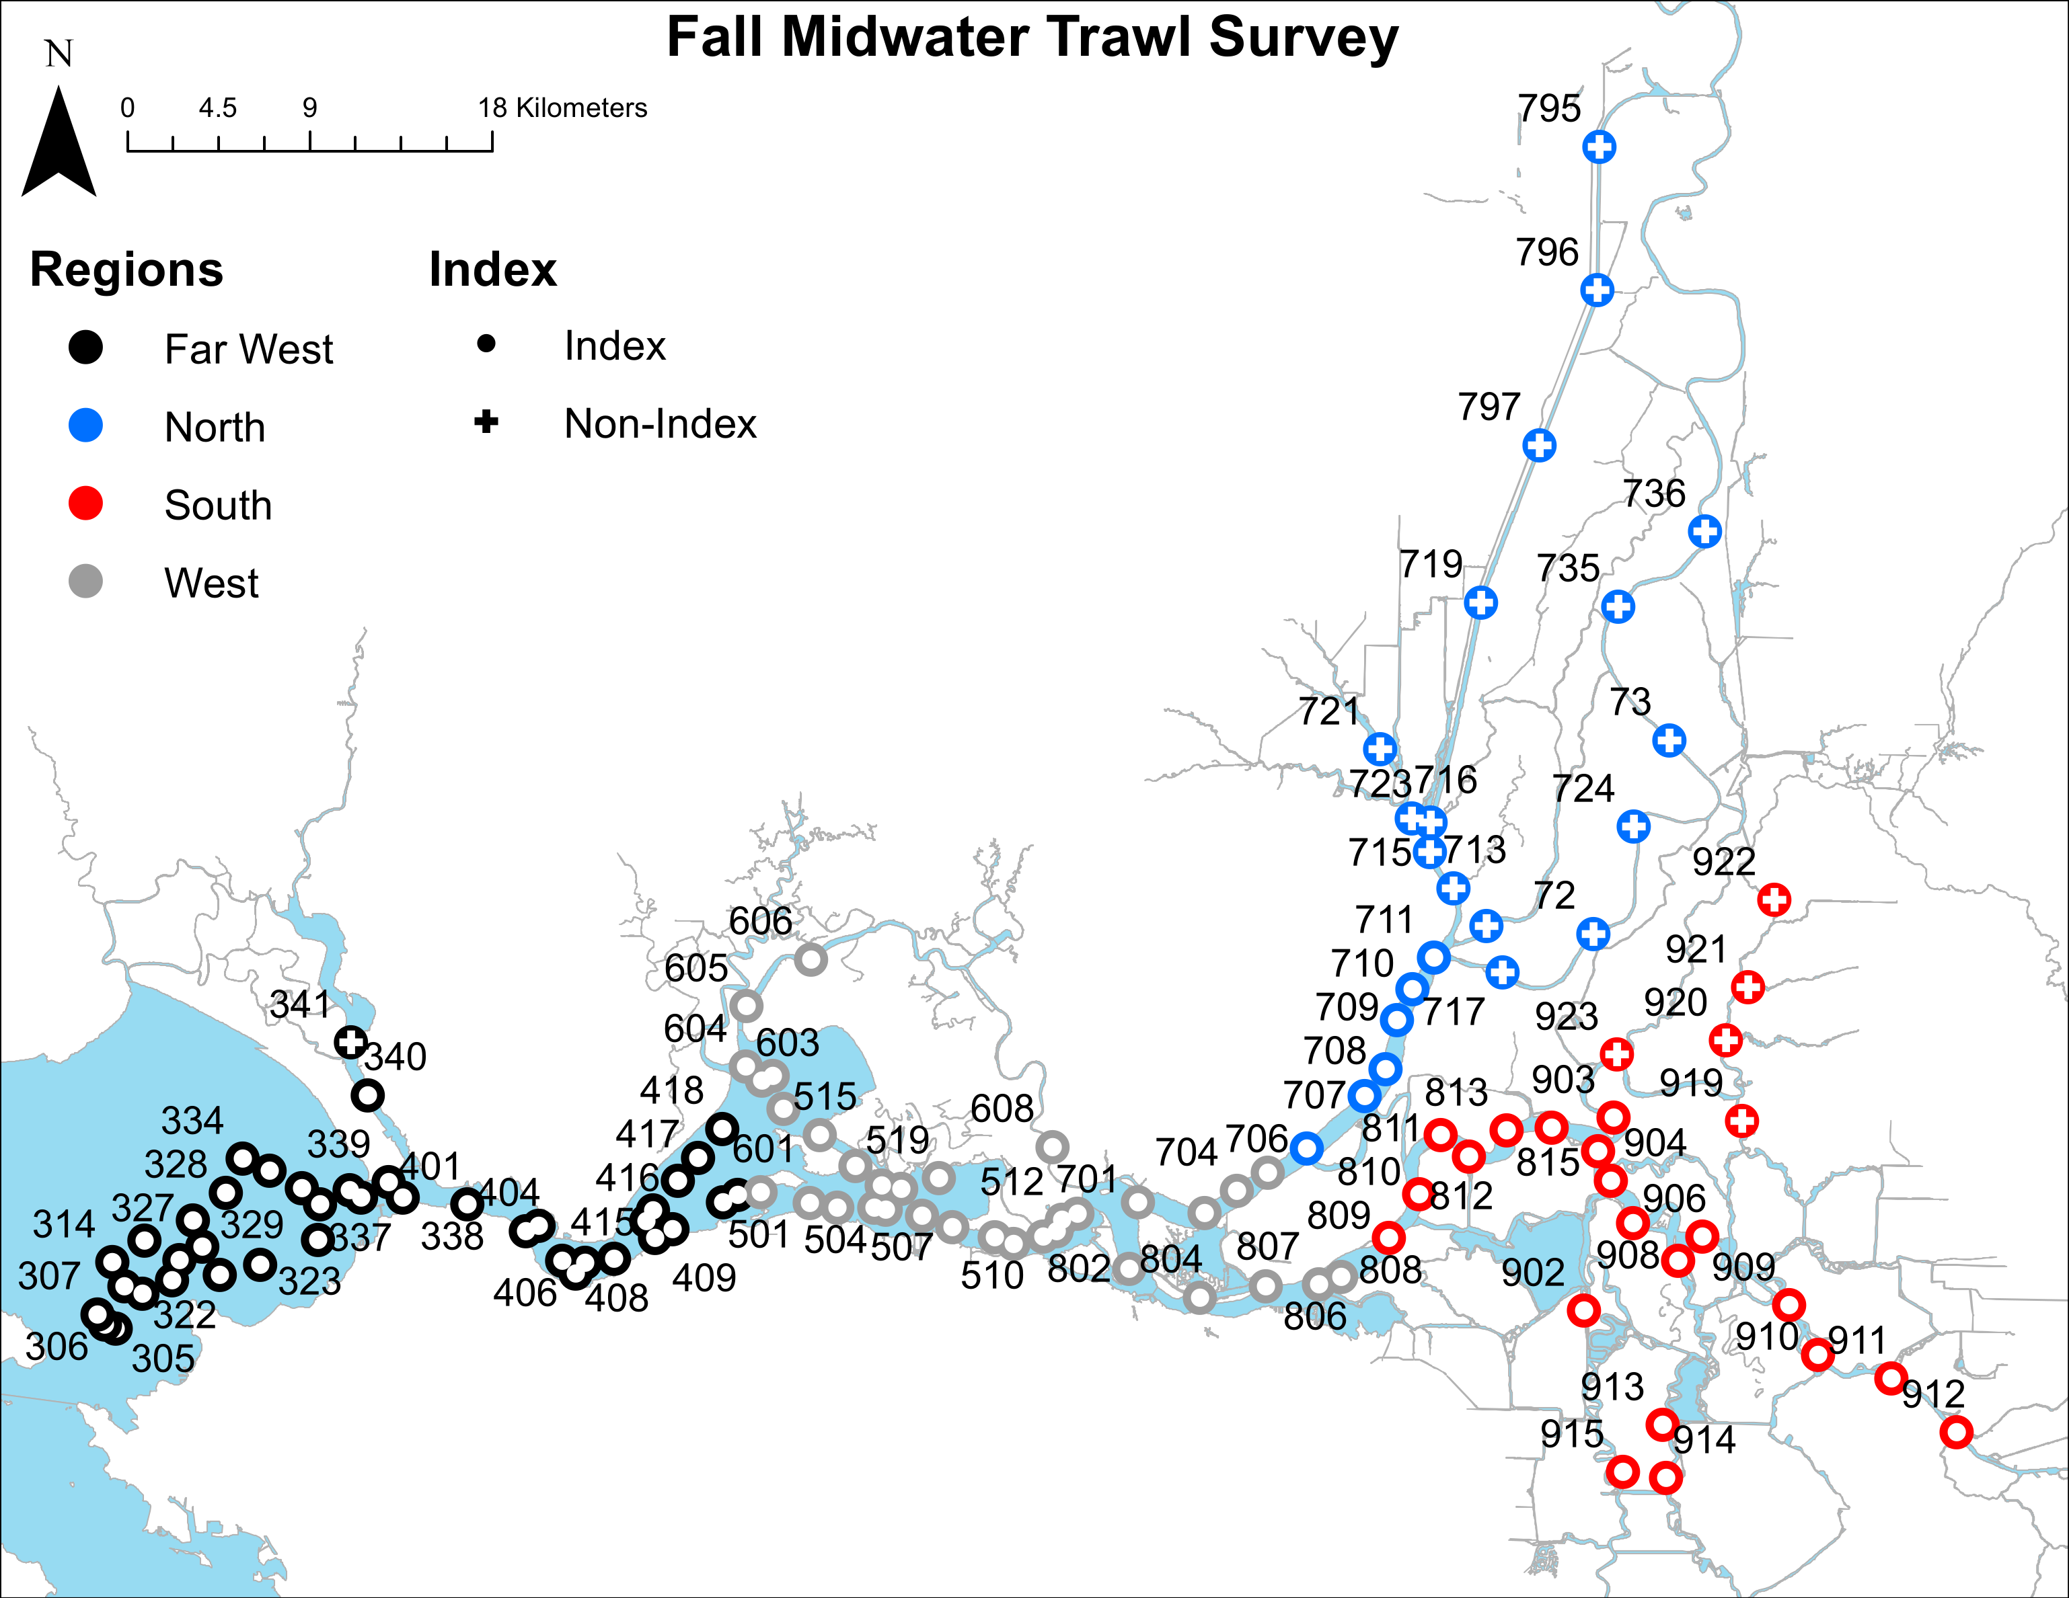

Figure 1. Map of FMWT station locations, regional groupings, and station index designations.

# Methods and Gear

The FMWT trawl net consists of a 12 x 12 ft mouth, 58 ft long, starting with 8 inch mesh near the mouth tapering down multiple mesh sizes to 1/2 inch stretched mesh at the cod end. The net is retrieved obliquely through the water column according to a tow schedule which varies with water depth. Metal planing doors fixed at each corner of the mouth of the net help keep the mouth open during sampling. Further details on sampling methods and gear can be found in the FMWT protocol document (<https://filelib.wildlife.ca.gov/Public/TownetFallMidwaterTrawl/FMWT%20Data/FMWT%20Protocol.pdf>).

The typical unit for reporting catch used below is catch per unit effort (CPUE). For FMWT, we calculate CPUE as total species catch divided by water volume of the trawl (as calculated from flowmeter values) in units of cubic hectares (i.e. catch per cubic hectare; see <https://filelib.wildlife.ca.gov/Public/TownetFallMidwaterTrawl/FMWT%20Data/CPUE%20and%20Index%20Calculation%20Instructions.doc>).

The crew typically includes an Environmental Scientist (ES), a Fish and Wildlife Scientific Aid (Sci Aid), and a Mate. The Mate is responsible for driving and maintaining the boat, while the ES and Sci Aid operate the winches, deploy the net, and conduct all sample collection. The survey currently takes 10-12 days to sample all 122 stations every month.

# 2020 Field Season

Despite many challenges this year from wildfire smoke from surrounding areas and a Coronavirus Disease 2019 (COVID-19) global pandemic, sampling was nearly complete at 121 fish tows and 31 zooplankton tows (Clark-Bumpus and Mysid nets) for each month of sampling in 2020 (Table 1). The exception was station 721 in Cache Slough, which has become increasingly overgrown with dense aquatic vegetation the past few years. This vegetation completely fouls our gear and makes effective sampling of this station impossible (Fig. 2). Besides routine sampling, additional zooplankton and phytoplankton sampling was conducted at 11 stations biweekly in September and October for the Suisun Marsh Salinity Control Gate study on behalf of the California Department of Water Resources (Table 1). Overall, 2020 sampling contributed to the FMWT annual abundance indices, USFWS Delta Smelt Recovery Index, and DWR Suisun Marsh Salinity Control Gate the DWR Suisun Marsh Salinity Control Gate (SMSCG) special study with addition of phytoplankton samples collected at a subset of stations.

The 2020 field season was filled with unique challenges due to COVID restrictions and wildfire smoke. In September, 3 field days were skipped due to harmful air quality levels resulting from large wildfires in the surrounding areas (Figure 2). These delays were made up later by running two boats/crews simultaneously, sampling different areas. Further delays were caused by diesel fuel shortages or faulty pumps at local marinas. This required shortened or extra-long days to make detours to other marinas. COVID restrictions prevented staff from carpooling which caused logistical challenges, a shortage of available work vehicles, and schedule changes to accommodate boat moves between marinas.

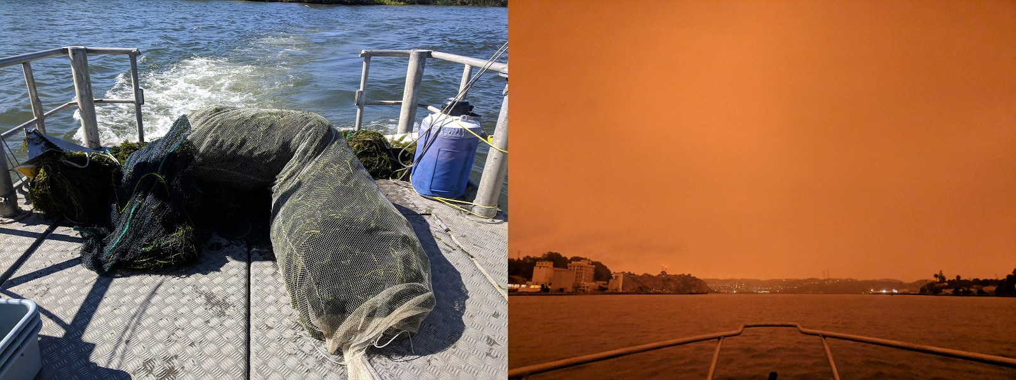

Figure 2. Challenges during field sampling in 2020. Left: Approximately 200 pounds of invasive aquatic vegetation fouling FMWT net at station 721 in Cache Slough. Right: Poor air quality canceled sampling on September 9, 2020. Photo taken September 9, 2020 at 7:34 am on the Napa River near Vallejo, CA.

Table 1. Number of Fish, Clark-Bumpus (CB), Mysid, and Phytoplankton samples collected at each station during the 2020 Fall Midwater Trawl Survey season conducted monthly September-December. All planned station sampling were accomplished with the exception of station 721 due to aquatic vegetation preventing sampling.

| Station | Region | Index | Delta Smelt Recovery Index | Fish net | CB net | Mysid net | Salinity Control Gate | Phytoplankton |
| --- | --- | --- | --- | --- | --- | --- | --- | --- |
| 305 | Far West | Index |  | 4 | 0 | 0 | 0 | 0 |
| 306 | Far West | Index |  | 4 | 0 | 0 | 0 | 0 |
| 307 | Far West | Index |  | 4 | 0 | 0 | 0 | 0 |
| 308 | Far West | Index |  | 4 | 0 | 0 | 0 | 0 |
| 309 | Far West | Index |  | 4 | 0 | 0 | 0 | 0 |
| 310 | Far West | Index |  | 4 | 0 | 0 | 0 | 0 |
| 311 | Far West | Index |  | 4 | 0 | 0 | 0 | 0 |
| 314 | Far West | Index |  | 4 | 0 | 0 | 0 | 0 |
| 315 | Far West | Index |  | 4 | 0 | 0 | 0 | 0 |
| 321 | Far West | Index |  | 4 | 0 | 0 | 0 | 0 |
| 322 | Far West | Index |  | 4 | 0 | 0 | 0 | 0 |
| 323 | Far West | Index |  | 4 | 0 | 0 | 0 | 0 |
| 325 | Far West | Index |  | 4 | 0 | 0 | 0 | 0 |
| 326 | Far West | Index |  | 4 | 0 | 0 | 0 | 0 |
| 327 | Far West | Index |  | 4 | 0 | 0 | 0 | 0 |
| 328 | Far West | Index |  | 4 | 0 | 0 | 0 | 0 |
| 329 | Far West | Index |  | 4 | 0 | 0 | 0 | 0 |
| 334 | Far West | Index |  | 4 | 0 | 0 | 0 | 0 |
| 335 | Far West | Index |  | 4 | 0 | 0 | 0 | 0 |
| 336 | Far West | Index |  | 4 | 0 | 0 | 0 | 0 |
| 337 | Far West | Index |  | 4 | 0 | 0 | 0 | 0 |
| 338 | Far West | Index |  | 4 | 0 | 0 | 0 | 0 |
| 339 | Far West | Index |  | 4 | 0 | 0 | 0 | 0 |
| 340 | Far West | Index |  | 4 | 0 | 0 | 0 | 0 |
| 341 | Far West | Non-Index |  | 4 | 0 | 0 | 0 | 0 |
| 401 | Far West | Index |  | 4 | 0 | 0 | 0 | 0 |
| 403 | Far West | Index |  | 4 | 0 | 0 | 0 | 0 |
| 404 | Far West | Index |  | 4 | 0 | 0 | 0 | 0 |
| 405 | Far West | Index |  | 4 | 4 | 4 | 0 | 0 |
| 406 | Far West | Index |  | 4 | 0 | 0 | 0 | 0 |
| 407 | Far West | Index |  | 4 | 0 | 0 | 0 | 0 |
| 408 | Far West | Index |  | 4 | 0 | 0 | 0 | 0 |
| 409 | Far West | Index |  | 4 | 0 | 0 | 0 | 0 |
| 410 | Far West | Index | Sept-Oct | 4 | 0 | 0 | 0 | 0 |
| 411 | Far West | Index |  | 4 | 4 | 4 | 0 | 0 |
| 412 | Far West | Index | Sept-Oct | 4 | 0 | 0 | 0 | 0 |
| 414 | Far West | Index | Sept-Oct | 4 | 0 | 0 | 0 | 0 |
| 415 | Far West | Index |  | 4 | 0 | 0 | 0 | 0 |
| 416 | Far West | Index | Sept-Oct | 4 | 4 | 4 | 2 | 0 |
| 417 | Far West | Index |  | 4 | 0 | 0 | 0 | 0 |
| 418 | Far West | Index | Sept-Oct | 4 | 4 | 4 | 0 | 0 |
| 413 | West | Index |  | 4 | 0 | 0 | 0 | 0 |
| 501 | West | Index | Sept-Oct | 4 | 4 | 4 | 0 | 0 |
| 502 | West | Index |  | 4 | 0 | 0 | 0 | 0 |
| 503 | West | Index | Sept-Oct | 4 | 0 | 0 | 0 | 0 |
| 504 | West | Index |  | 4 | 4 | 4 | 0 | 0 |
| 505 | West | Index | Sept-Oct | 4 | 0 | 0 | 0 | 0 |
| 507 | West | Index | Sept-Oct | 4 | 0 | 0 | 0 | 0 |
| 508 | West | Index |  | 4 | 4 | 4 | 2 | 0 |
| 509 | West | Index | Sept-Oct | 4 | 0 | 0 | 0 | 0 |
| 510 | West | Index |  | 4 | 0 | 0 | 0 | 0 |
| 511 | West | Index | Sept-Oct | 4 | 0 | 0 | 0 | 0 |
| 512 | West | Index |  | 4 | 0 | 0 | 0 | 0 |
| 513 | West | Index | Sept-Oct | 4 | 4 | 4 | 2 | 0 |
| 515 | West | Index | Sept-Oct | 4 | 0 | 0 | 0 | 0 |
| 516 | West | Index |  | 4 | 0 | 0 | 0 | 0 |
| 517 | West | Index | Sept-Oct | 4 | 0 | 0 | 0 | 0 |
| 518 | West | Index |  | 4 | 0 | 0 | 0 | 0 |
| 519 | West | Index | Sept-Oct | 4 | 4 | 4 | 2 | 0 |
| 601 | West | Index |  | 4 | 0 | 0 | 0 | 0 |
| 602 | West | Index | Sept-Oct | 4 | 4 | 4 | 2 | 0 |
| 603 | West | Index |  | 4 | 0 | 0 | 0 | 0 |
| 604 | West | Index | Sept-Oct | 4 | 0 | 0 | 0 | 0 |
| 605 | West | Index |  | 4 | 1 | 1 | 2 | 3 |
| 606 | West | Index | Sept-Oct | 4 | 4 | 4 | 2 | 3 |
| 608 | West | Index | Sept-Oct | 4 | 4 | 4 | 0 | 0 |
| 701 | West | Index | Sept-Oct | 4 | 0 | 0 | 0 | 0 |
| 703 | West | Index | Sept-Oct | 4 | 0 | 0 | 0 | 0 |
| 704 | West | Index |  | 4 | 4 | 4 | 2 | 3 |
| 705 | West | Index | Sept-Oct | 4 | 0 | 0 | 0 | 0 |
| 802 | West | Index | Sept-Oct | 4 | 4 | 4 | 2 | 3 |
| 804 | West | Index | Sept-Oct | 4 | 4 | 4 | 0 | 0 |
| 806 | West | Index | Sept-Oct | 4 | 0 | 0 | 0 | 0 |
| 807 | West | Index |  | 4 | 0 | 0 | 0 | 0 |
| 808 | West | Index | Sept-Oct | 4 | 0 | 0 | 0 | 0 |
| 706 | North | Index |  | 4 | 4 | 4 | 2 | 3 |
| 707 | North | Index | Sept-Oct | 4 | 4 | 4 | 2 | 0 |
| 708 | North | Index |  | 4 | 0 | 0 | 0 | 0 |
| 709 | North | Index | Sept-Oct | 4 | 0 | 0 | 0 | 0 |
| 710 | North | Index |  | 4 | 0 | 0 | 0 | 0 |
| 711 | North | Index |  | 4 | 6 | 6 | 0 | 0 |
| 712 | North | Non-Index |  | 4 | 0 | 0 | 0 | 0 |
| 713 | North | Non-Index |  | 4 | 0 | 0 | 0 | 0 |
| 715 | North | Non-Index |  | 4 | 0 | 0 | 0 | 0 |
| 716 | North | Non-Index |  | 4 | 4 | 4 | 0 | 0 |
| 717 | North | Non-Index |  | 4 | 0 | 0 | 0 | 0 |
| 719 | North | Non-Index |  | 4 | 4 | 4 | 0 | 0 |
| 72 | North | Non-Index |  | 4 | 0 | 0 | 0 | 0 |
| 723 | North | Non-Index |  | 4 | 4 | 4 | 0 | 0 |
| 721 | North | Non-Index |  | 0 | 0 | 0 | 0 | 0 |
| 724 | North | Non-Index |  | 4 | 0 | 0 | 0 | 0 |
| 73 | North | Non-Index |  | 4 | 0 | 0 | 0 | 0 |
| 735 | North | Non-Index |  | 4 | 0 | 0 | 0 | 0 |
| 736 | North | Non-Index |  | 4 | 0 | 0 | 0 | 0 |
| 795 | North | Non-Index |  | 4 | 4 | 4 | 0 | 0 |
| 796 | North | Non-Index |  | 4 | 4 | 4 | 0 | 0 |
| 797 | North | Non-Index |  | 4 | 4 | 4 | 0 | 0 |
| 809 | South | Index |  | 4 | 4 | 3 | 0 | 0 |
| 810 | South | Index | Sept-Oct | 4 | 0 | 0 | 0 | 0 |
| 811 | South | Index |  | 4 | 0 | 0 | 0 | 0 |
| 812 | South | Index | Sept-Oct | 4 | 4 | 4 | 0 | 0 |
| 813 | South | Index |  | 4 | 0 | 0 | 0 | 0 |
| 814 | South | Index | Sept-Oct | 4 | 0 | 0 | 0 | 0 |
| 815 | South | Index |  | 4 | 4 | 3 | 0 | 0 |
| 902 | South | Index |  | 4 | 0 | 0 | 0 | 0 |
| 903 | South | Index | Sept-Oct | 4 | 0 | 0 | 0 | 0 |
| 904 | South | Index | Sept-Oct | 4 | 0 | 0 | 0 | 0 |
| 905 | South | Index |  | 4 | 0 | 0 | 0 | 0 |
| 906 | South | Index | Sept-Oct | 4 | 4 | 4 | 0 | 0 |
| 908 | South | Index | Sept-Oct | 4 | 0 | 0 | 0 | 0 |
| 909 | South | Index |  | 4 | 0 | 0 | 0 | 0 |
| 910 | South | Index |  | 4 | 4 | 4 | 0 | 0 |
| 911 | South | Index |  | 4 | 0 | 0 | 0 | 0 |
| 912 | South | Index |  | 4 | 4 | 4 | 0 | 0 |
| 913 | South | Index |  | 4 | 0 | 0 | 0 | 0 |
| 914 | South | Index |  | 4 | 0 | 0 | 0 | 0 |
| 915 | South | Index |  | 4 | 0 | 0 | 0 | 0 |
| 919 | South | Non-Index |  | 4 | 4 | 4 | 0 | 0 |
| 920 | South | Non-Index |  | 4 | 0 | 0 | 0 | 0 |
| 921 | South | Non-Index |  | 4 | 0 | 0 | 0 | 0 |
| 922 | South | Non-Index |  | 4 | 0 | 0 | 0 | 0 |
| 923 | South | Non-Index |  | 4 | 0 | 0 | 0 | 0 |
| Total |  |  |  | 484 | 127 | 125 | 22 | 15 |

# Abiotic variables

## Water clarity

Secchi disk depth (cm) varied considerably across the estuary (Fig. 3). Generally, water was least clear throughout Carquinez Strait (stations in the 400s), Suisun Bay (Stations in the 500-600 range), and the upper portion of the Sacramento River Deep Water Shipping Channel (stations 795-797; DWSC). In September, a southern DWSC station saw an unusually high secchi value of almost 500 centimeters. Water was relatively clear (200-300 cm secchi depth) throughout the southern and eastern stations (stations in the 900s) for the entirety of the survey. Previous studies have documented a negative correlation between fish catch and high Secchi values (MacNally et al. 2010), which varies between species. For example, larval Longfin Smelt are more likely to be caught in the secchi depth range of 0-80 cm (Grimaldo et al. 2017) and adult Longfin Smelt catch is greatest at depths less than 50 cm (Lewis et al. 2019). Latour (2016) found CPUE decreased 75% once secchi depth reach 35, 50, 53, and 112 cm for Delta Smelt, Longfin Smelt, Age-0 Striped Bass, and Threadfin Shad, respectively. Therefore, in the heatmap of secchi values below (Fig. 3), stations with dark purple boxes (<100 cm secchi depth) represent stations with the highest likelihood of fish occurrence, which quickly decreases as the color scale transitions to blues, greens, and yellow.

Turbidity (NTU) is a similar but more precise metric of measuring water clarity compared to secchi depth. Higher turbidity values indicate more opaque water. The heatmap of turbidity values during the 2020 FMWT survey (Fig. 4) show a similar pattern as the secchi values. The northern part of the DWSC, northern Suisun Bay/Montezuma Slough, and Carquinez Strait showed the most turbidity while the rest of the estuary was relatively clear.

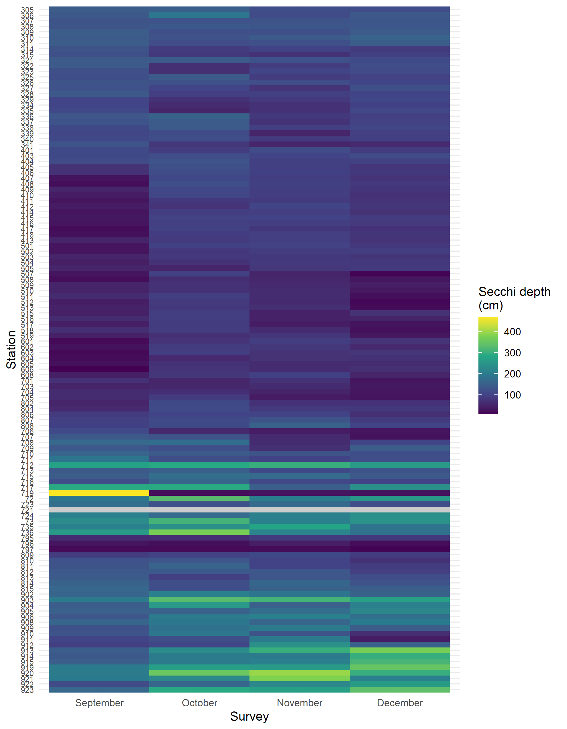

Figure 3. Heatmap of monthly secchi disk values (cm) recorded during the 2020 FMWT season. Dark purple values represent the most suitable conditions for many fish species with preference for turbidity.

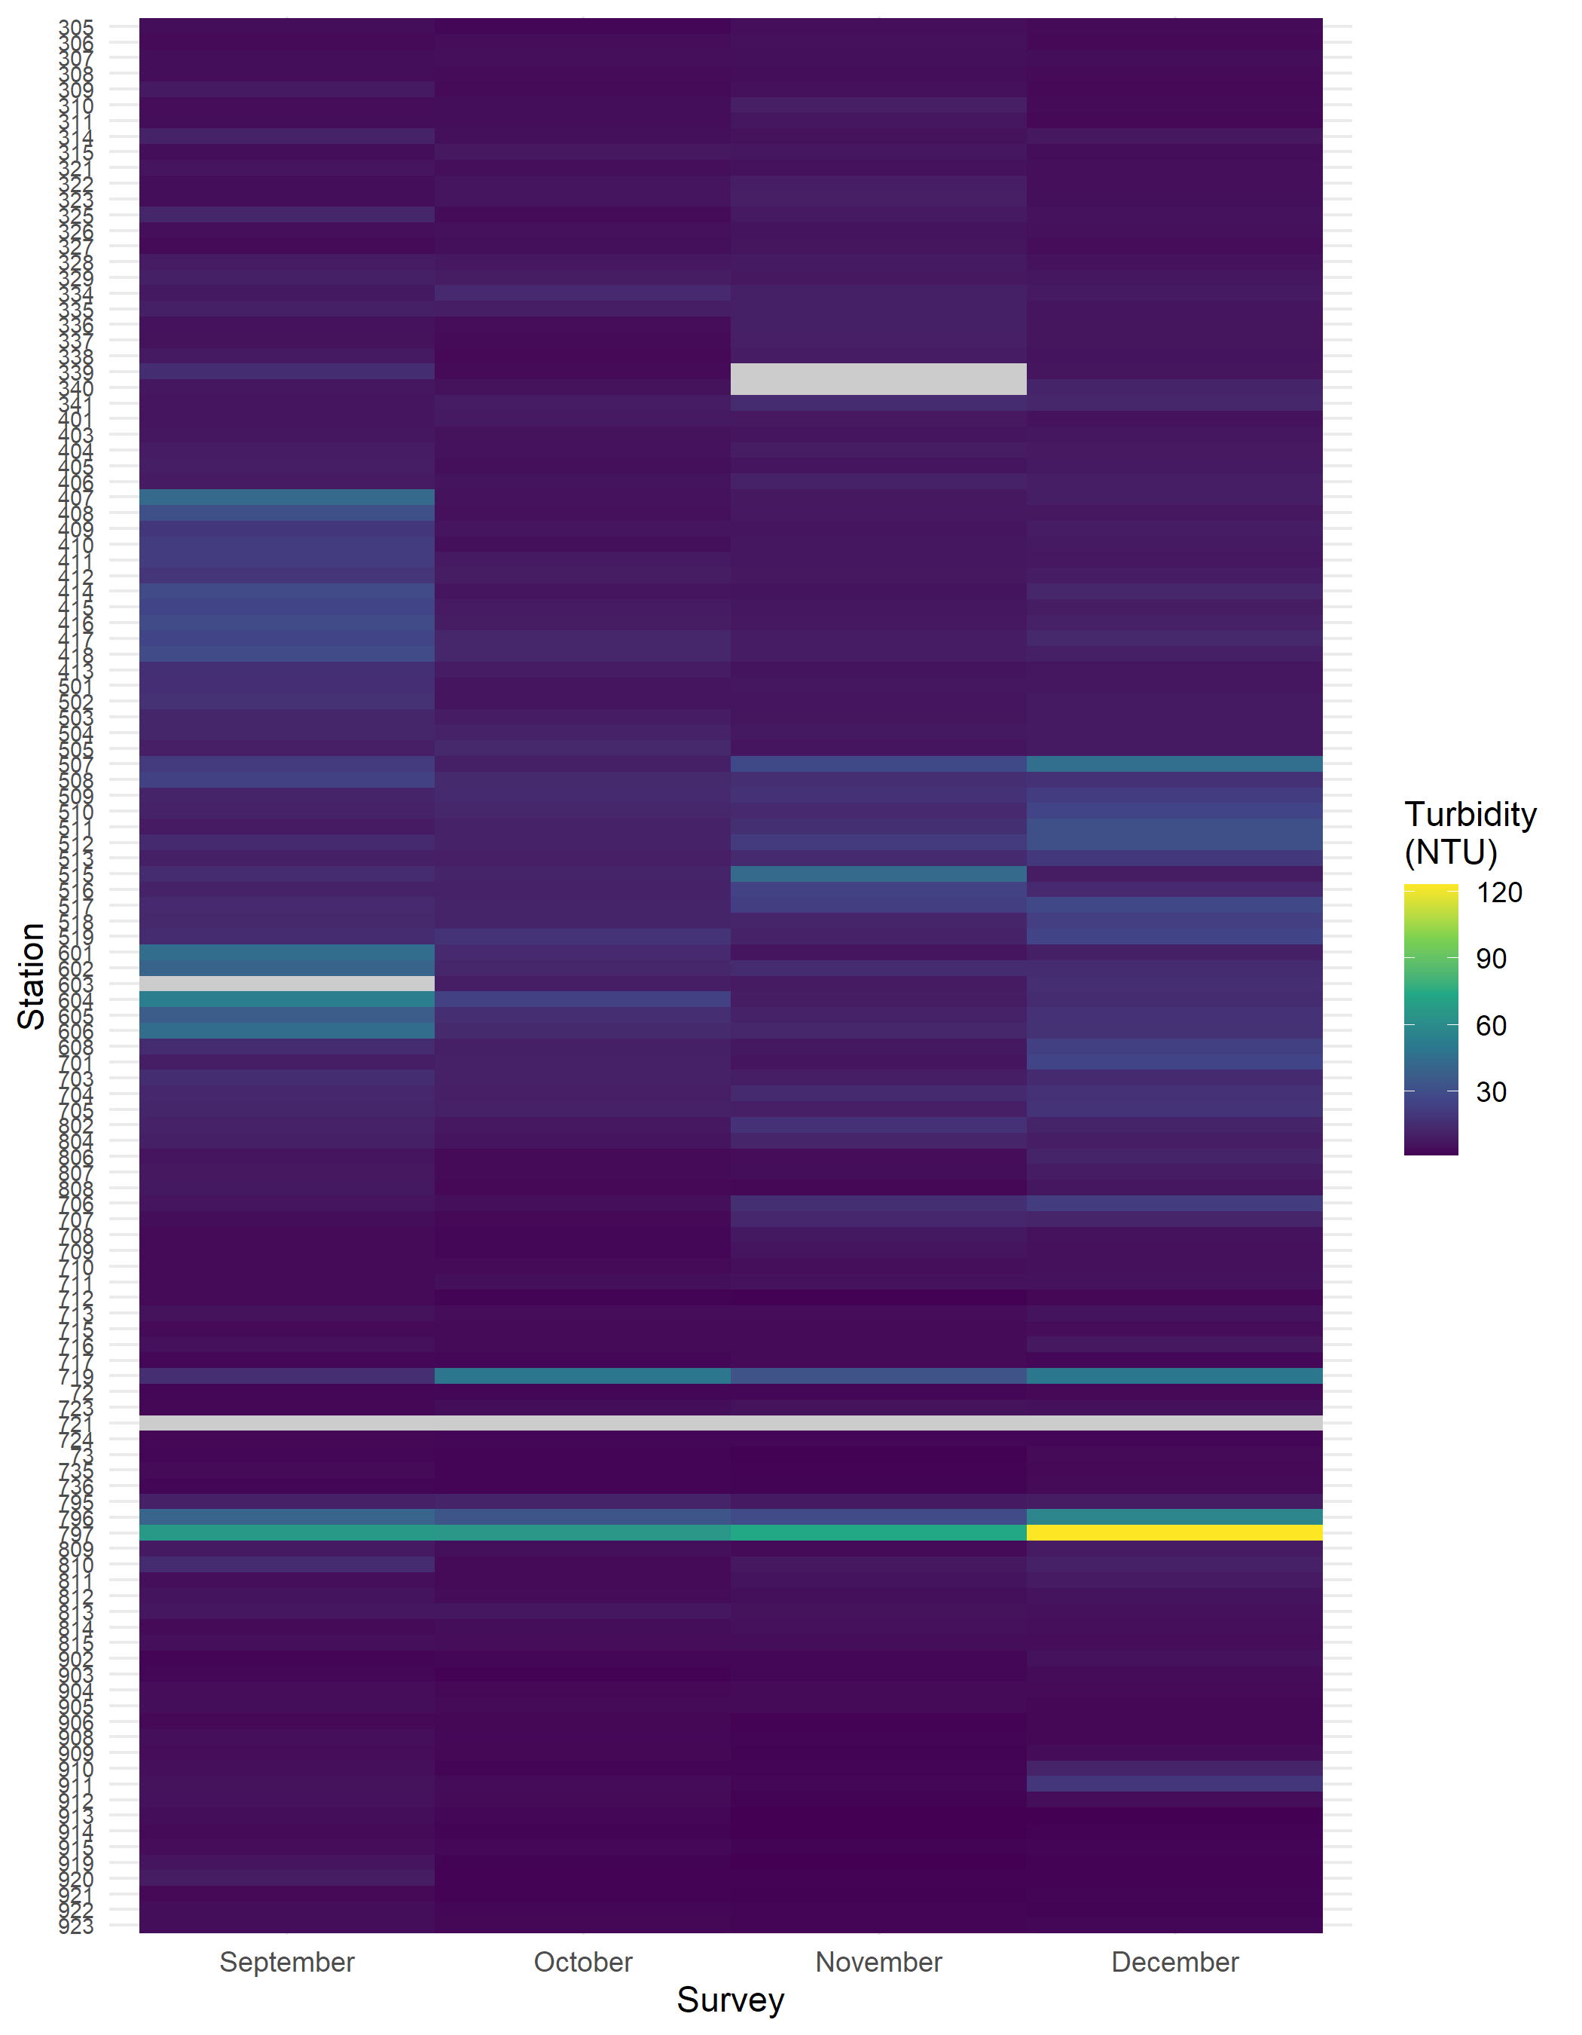

Figure 4. Heatmap of surface water turbidity (NTU) recorded during the 2020 FMWT season. Grey values indicate missing data. The northern part of the DWSC, western and northern Suisun Bay were the most turbid regions.

## Temperature

Many estuary species have habitat preferences that include a range of suitable water temperatures (Baker et al. 1995; Swanson et al. 2000; Moyle et al. 2004; Bennett 2005). Past research has linked long term seasonal Delta Smelt occurrence with changes in abiotic habitat metrics such as temperature (Feyrer et al. 2007; Nobriga et al. 2008; Feyrer et al. 2011). Other research has shown adult Longfin Smelt prefer temperatures under 17.8 °C (Hobbs and Moyle 2015), larval Longfin Smelt are most abundant in the 8-12 °C range (Grimaldo et al. 2017) and adults are most abundant in water 12-16 °C (Lewis et al. 2019). Also, Longfin Smelt tend to spawn when temperatures are between 7-14.5 °C (Moyle 2002) and Delta Smelt are likely to stop spawning once temperatures are greater than 20 °C (Swanson et al. 2000).

Besides preferences, there are physiological thermal limitations that have been documented for some species. For instance, Jeffries et al. (2016) found Longfin Smelt show a cellular stress response once water temperature is greater or equal to 20 °C and Bennett (2005) showed Delta Smelt experience mortality at temperatures above 25 °C.

The heatmap of surface water temperature (Fig. 5) shows temperatures throughout most of the estuary remained very high, possibly at the upper range of thermal tolerance for many fish species throughout September and October. By November, temperatures had cooled a bit, but remained relatively high in most regions except the upper San Joaquin and upper Sacramento Rivers, and the DWSC. By December, the water cooled to preferential levels estuary wide.

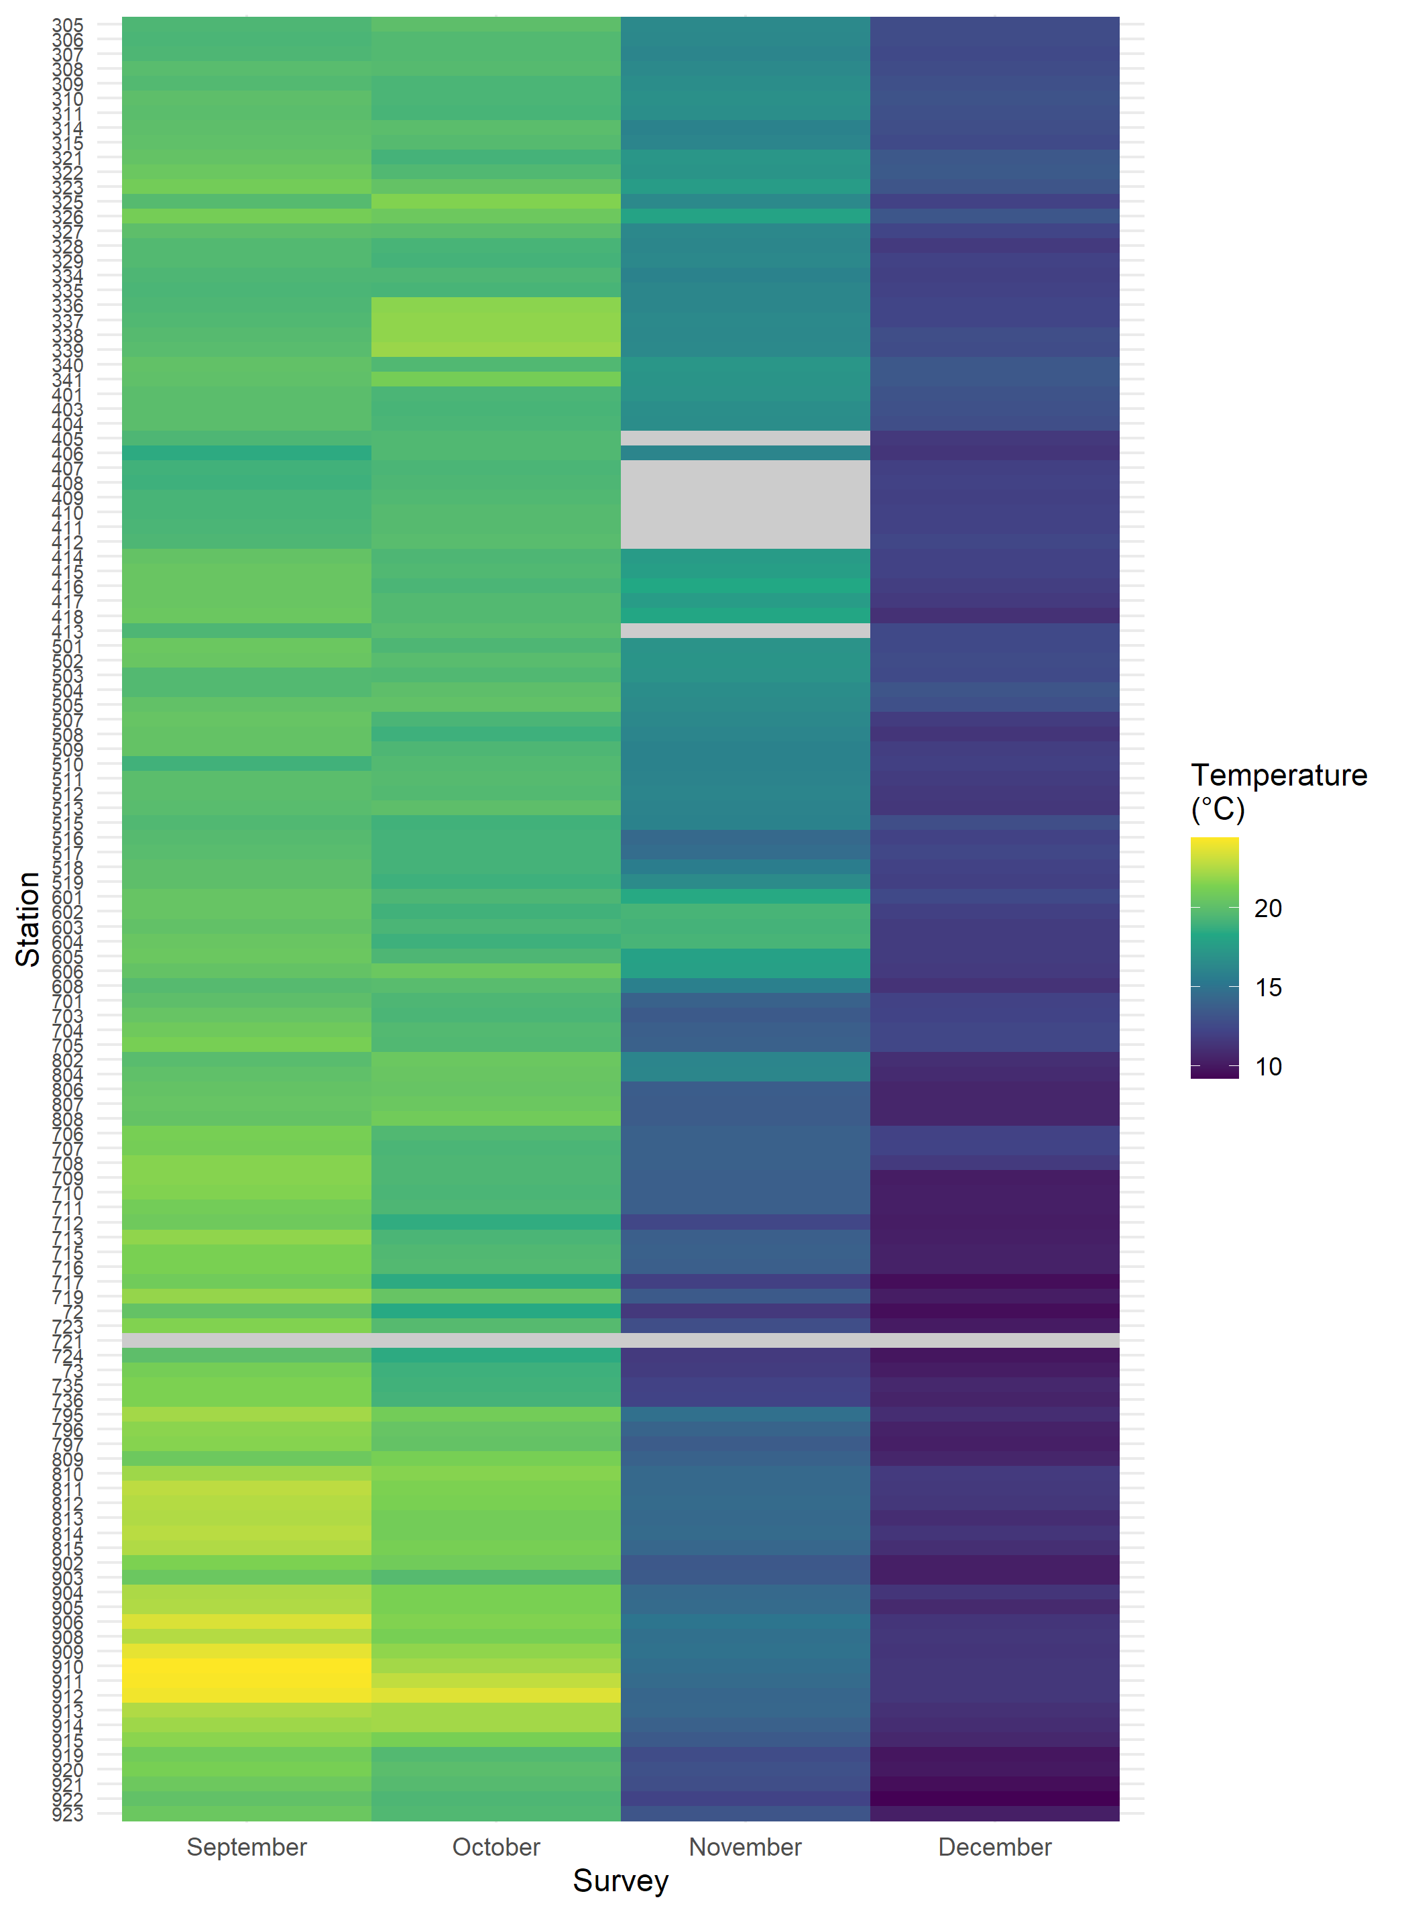

Figure 5. Heatmap of monthly surface water temperature (°C) recorded during the 2020 FMWT season. Grey values indicate missing data. Temperature values at 20 °C or greater induce cellular stress in Longfin Smelt and values above 25 °C induce Delta Smelt mortality, therefore stations in the purple and blue ranges are most suitable. Stations in the green to yellow range are potentially unsuitable for many species.

## Temperature and Water Clarity

Leveraging the 50+ year FMWT dataset, I created a series of regional maps showing Longfin Smelt habitat suitability from combined Secchi and temperature values for 2020 (Fig. 6). This map displays the average monthly temperature and secchi values in the regions FMWT samples and plots these values on a combined color scale. The breaks in this scale were first determined by plotting a cumulative frequency distribution of Longfin Smelt catch over the entire history of the survey compared to temperature and secchi separately (Fig. 7). Then taking the corresponding temperature and secchi values for each of the catch quantiles. These maps show the estuary was largely unsuitable for Longfin Smelt (and likely other species) in September through October. In November, Suisun Bay, Napa River, and the DWSC were in the highest tier of combined temperature and secchi values. By December, Napa River, the greater Suisun region and the DWSC were all more suitable (Fig. 6).

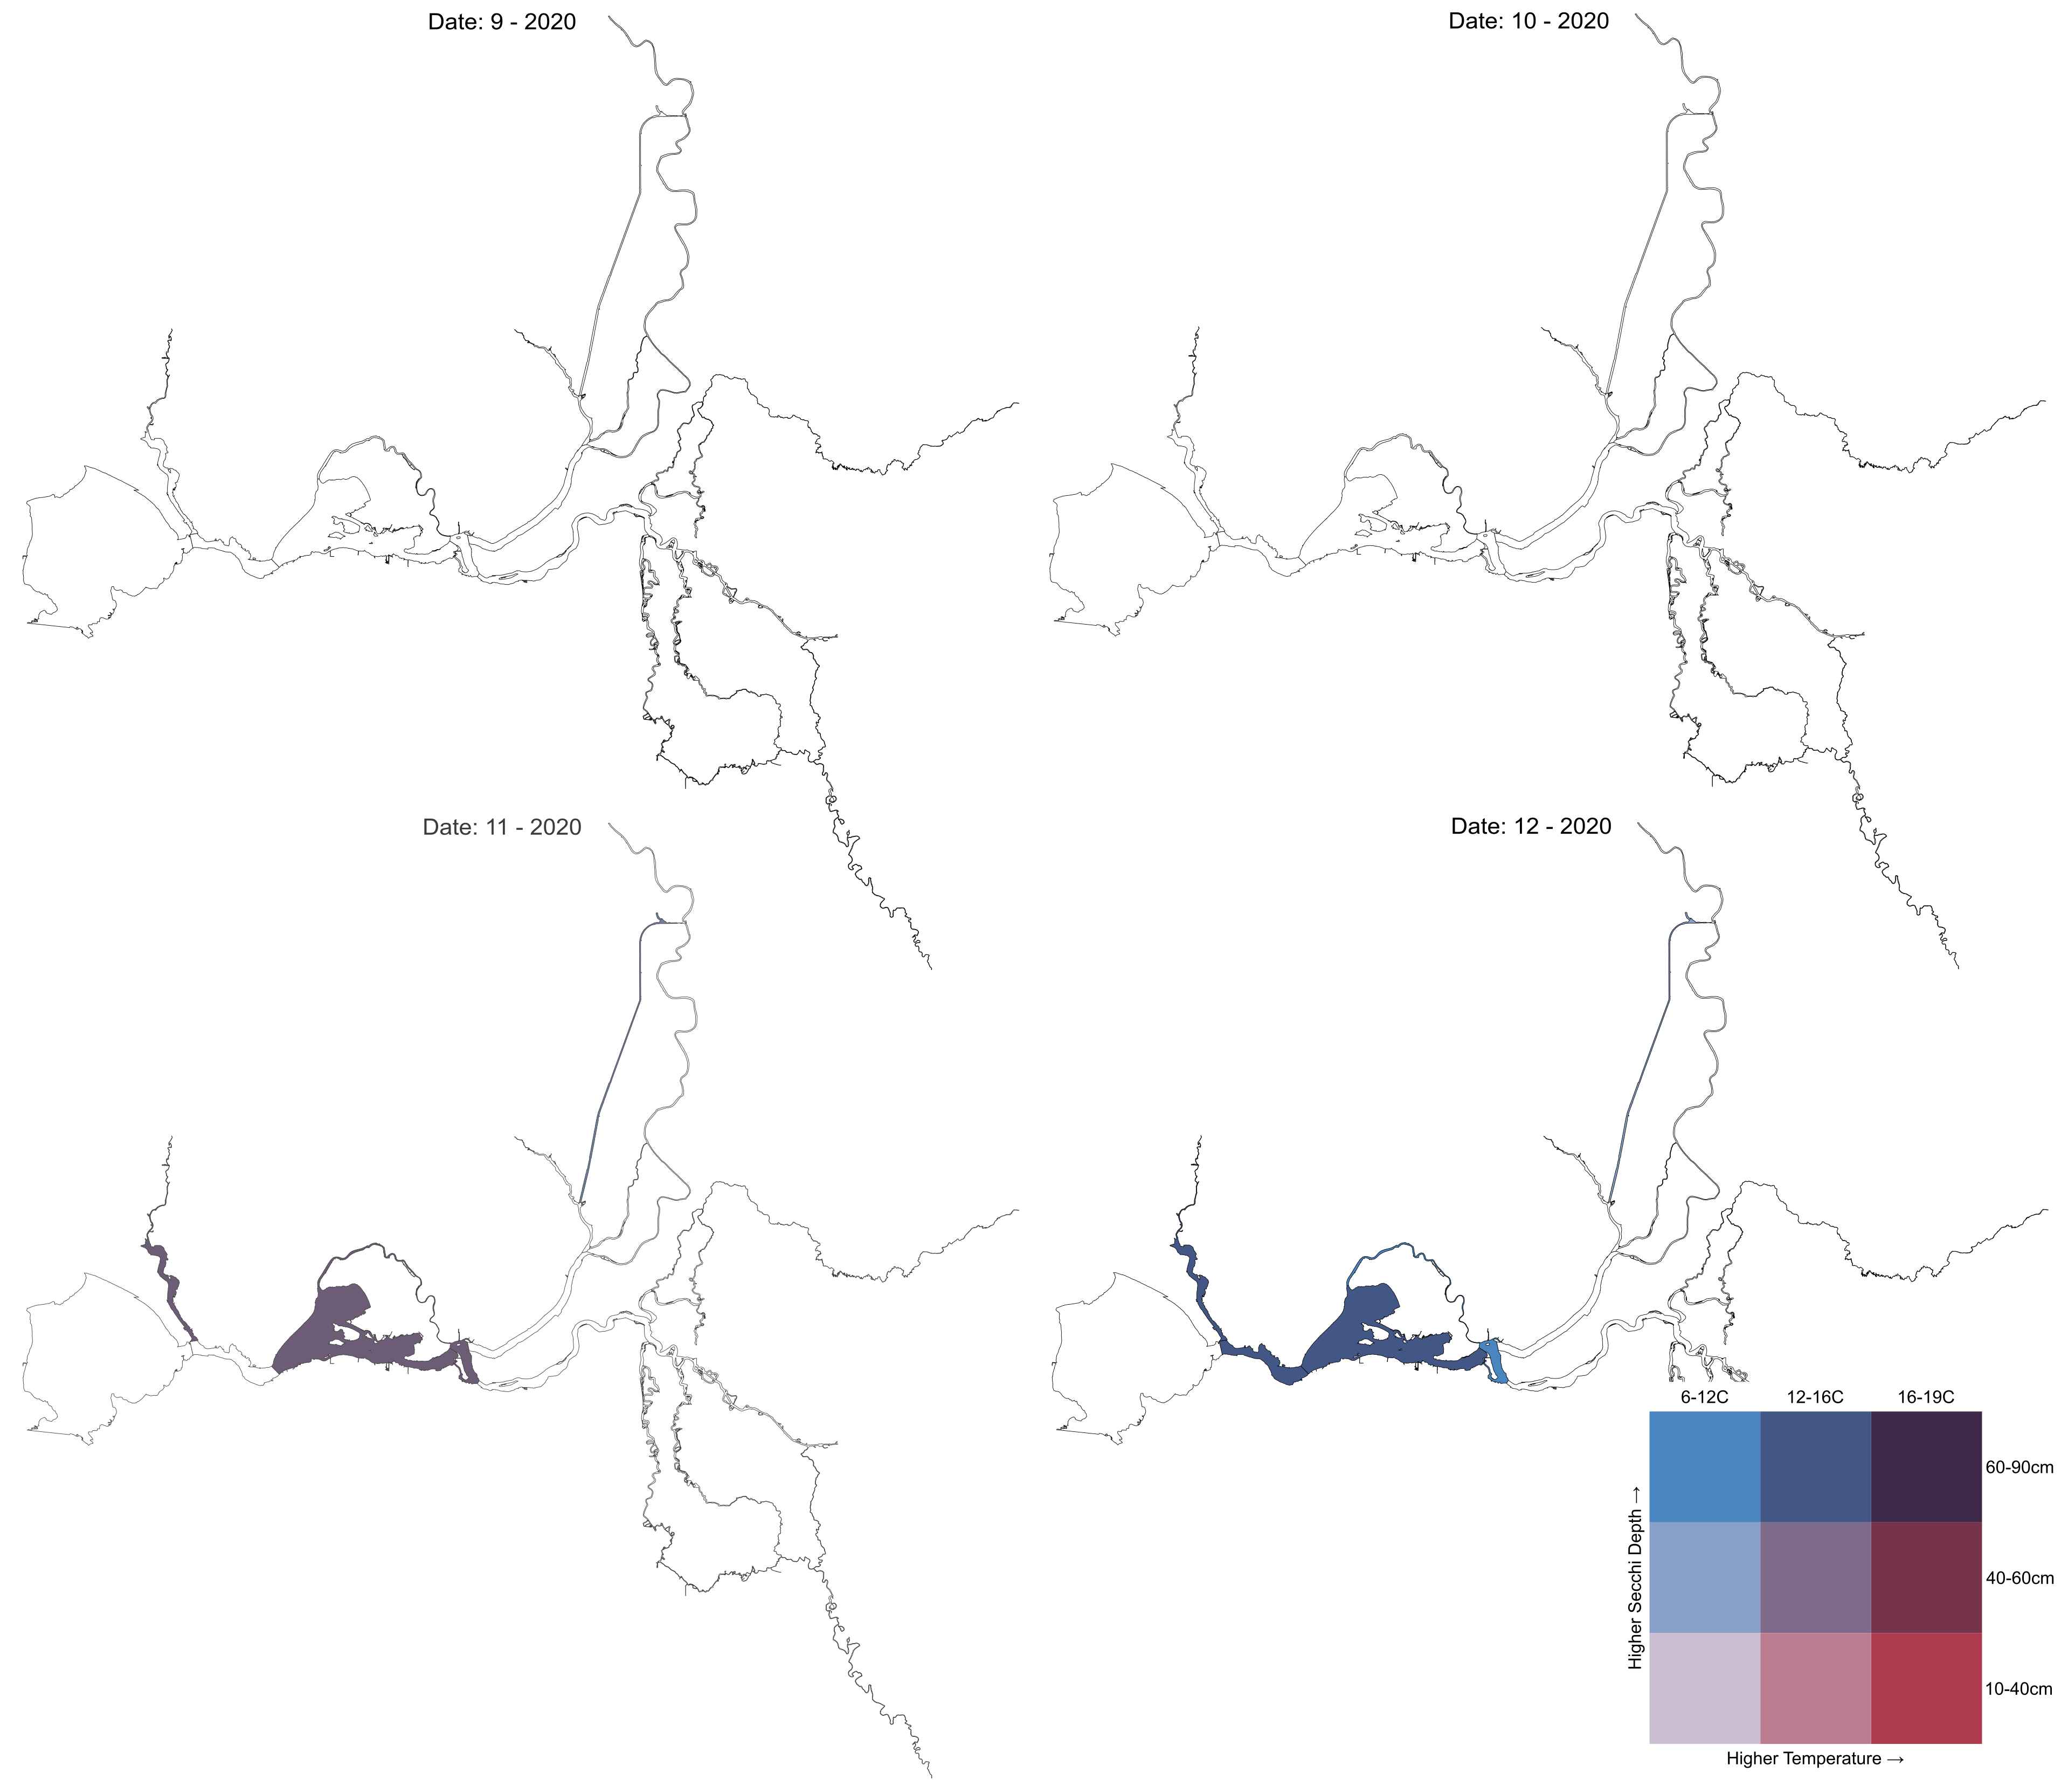

Figure 6. Map showing Longfin Smelt habitat suitability across each month of FMWT sampling in 2020 according to historical catch. White regions indicate values were out of suitable range. The habitat suitability was limited throughout the estuary until November, when Suisun Bay, Napa River, and the DWSC reaches the high end of suitability. By December, the central regions and the DWSC were more suitable.

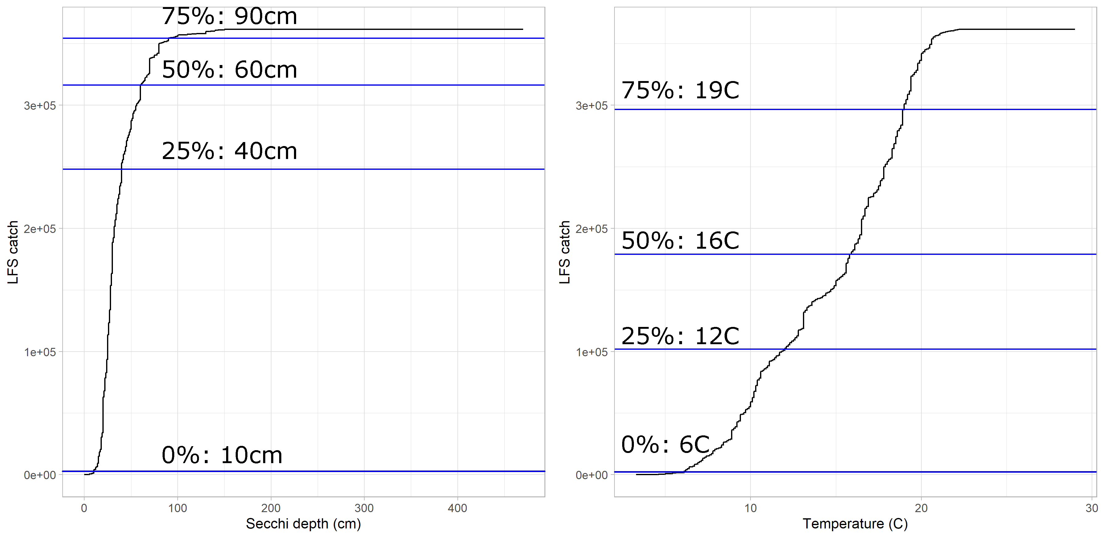

Figure 7. Cumulative frequency distributions of FMWT Longfin Smelt catch from 1967-2020 with abiotic variables. Left: Associated secchi depth (cm) with catch and quartile values. Right: Associated surface water temperature (C) with catch and quartile values.

## Salinity

In the San Francisco upper estuary, the low-salinity zone (LSZ, salinity 0.5-6 ppt) is recognized as an important nursery habitat for young fishes, partially due to the relatively high abundances of their zooplanktonic prey (Kimmerer 2002 a; Kimmerer 2002 b; Bennett 2005) and correlation with water clarity (Kimmerer et al. 1998; Schoellhamer 2000). A few species in the estuary have been documented to modify migration behavior to stay in this preferred salinity zone under different hydrodynamic conditions (Bennett et al. 2002; Kimmerer 2002 a; Kimmerer 2002 b). Temporal variability in freshwater outflow regulates the position of the LSZ (Jassby et al. 1995; Hobbs et al. 2006) which can occur as far west as the Carquinez Strait under high outflow or as far east as the lower Sacramento River and Delta under low outflow conditions (Hobbs et al. 2006). The heatmap of salinity values observed during the 2020 FMWT showed this LSZ remained inland, at the confluence of the Sacramento and San Joaquin rivers and eastward (Fig. 8). Carquinez Strait and Suisun Bay had moderate salinity levels which increased slightly towards the end of the year. This corresponds well with the low outflow observed during this period of a “Below Average” water year as classified by the Department of Water Resources.

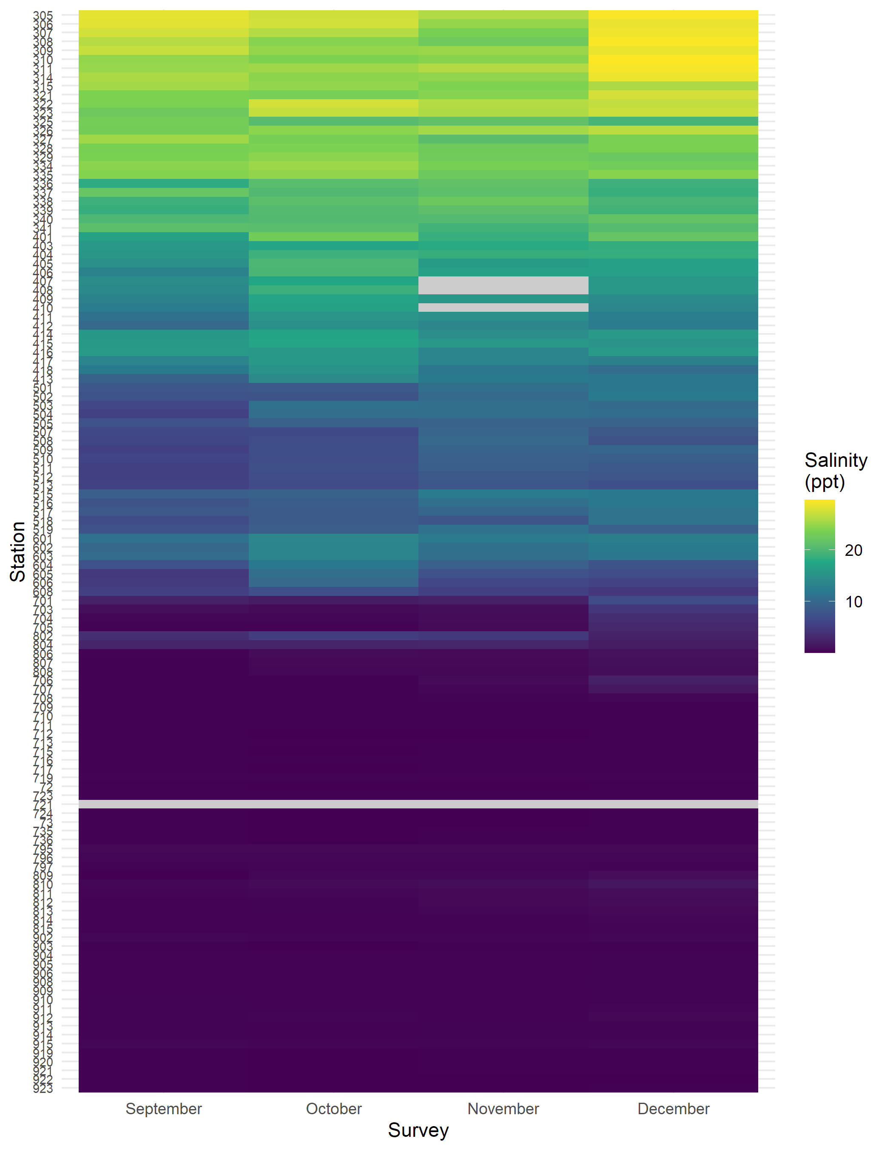

Figure 8. Heatmap of monthly surface water salinity (ppt) recorded during the 2020 FMWT season. Grey values indicate missing data. The low salinity zone (1-6 ppt, dark purple stations) stayed inland upstream of the confluence.

## *Microcystis*

The colonial cyanobacteria *Microcystis aeruginosa* was first discovered in the San Francisco Bay estuary in the early 2000s (Lehman et al. 2005). *Microcystis* in high abundance has toxic effects in the local food web, accumulating in dominant zooplankton species (Ger et al. 2010) and bioaccumulating up the trophic levels to predatory fish (Lehman et al. 2010). *Microcystis* becomes seasonally abundant during periods of low water flow and high water temperature (Lehman et al. 2008). FMWT assigns a qualitative rank of 1-5 based on visual inspection for flakes (Fig. 9(Morris and Civiello 2013)). During the 2020 FMWT survey, *Microcystis* was found to be in high abundance at stations throughout the southern and eastern Delta and moderate in parts of Carquinez Strait, Suisun Bay, Montezuma Slough, and the lower Sacramento River in September and October (Fig. 10). By November, a handful of stations in the southern Delta still had moderate *Microcystis* levels. In December, the estuary was cool enough where *Microcystis* was not detected anywhere.

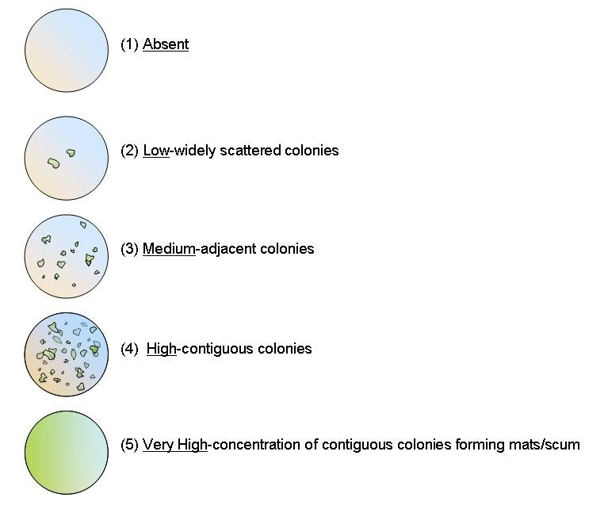

Figure 9. Qualitative rankings used to assess *Microcystis aeruginosa* blooms on the water surface.

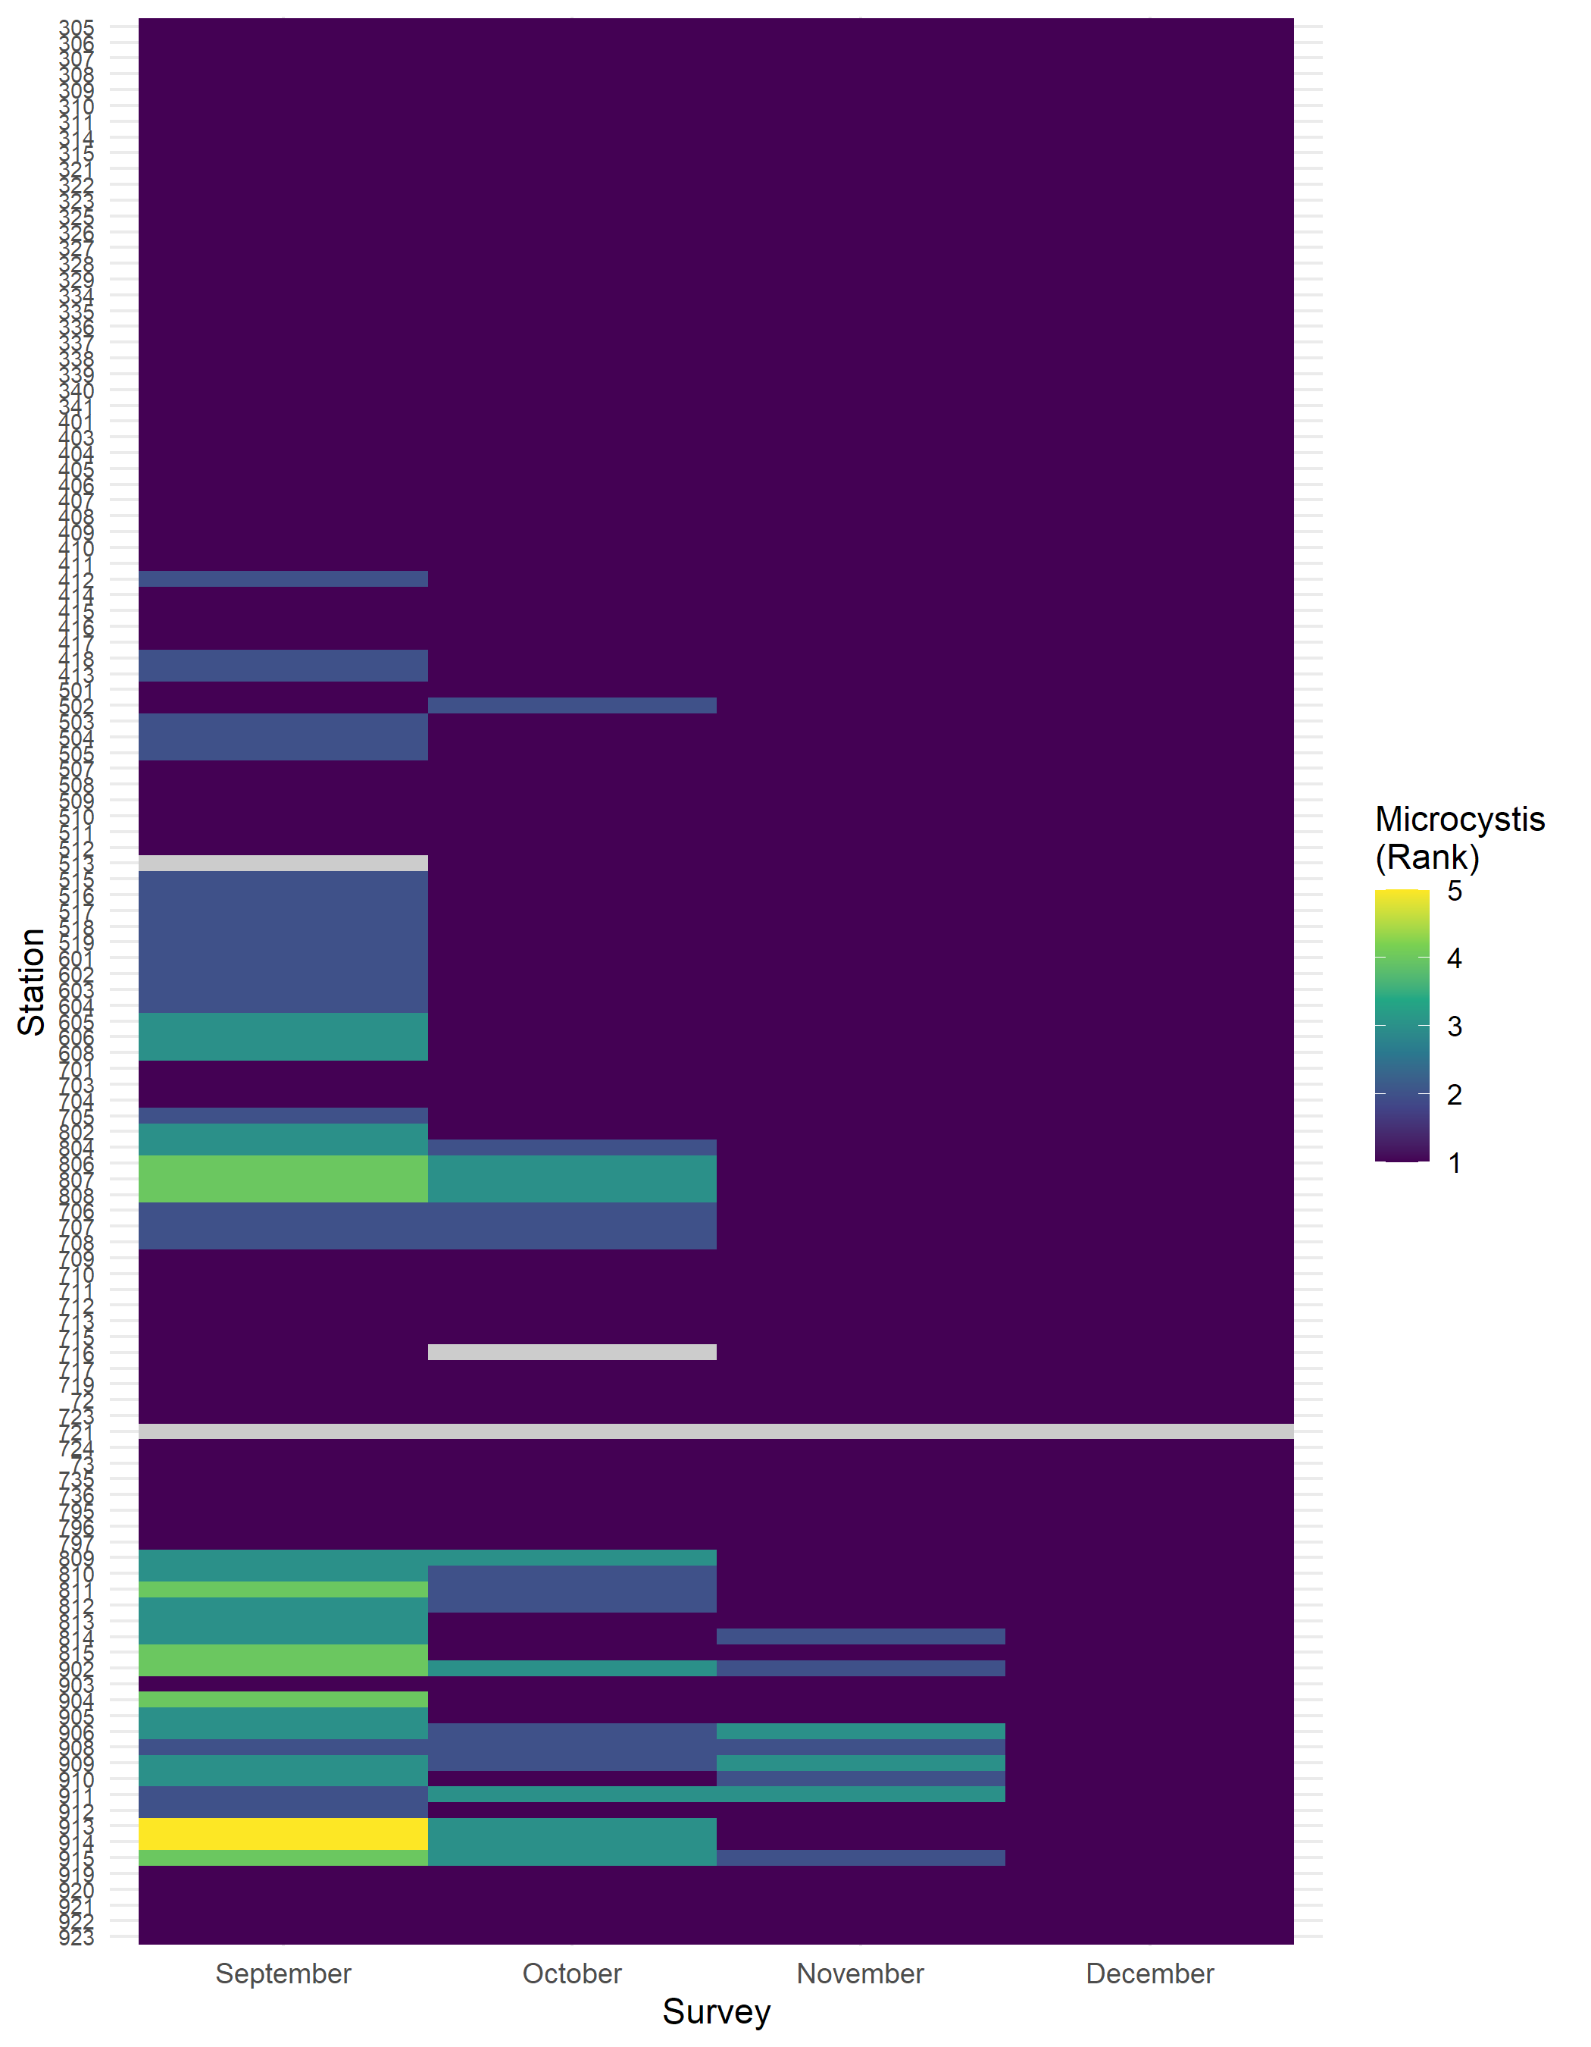

Figure 10. Heatmap of *Microcystis spp.* rankings recorded during the 2020 FMWT season. Grey values indicate missing data. Scale is a qualitative assessment of *Microcystis* density.

# Fish & Invertebrate Catch

## Fish

The FMWT survey records all species of fish and invertebrates caught in the trawl net having recorded over 100 different species to date. Since the onset of the Pelagic Organism Decline (Sommer et al. 2007) in the early 2000s, catch has been concentrated in a few regions of the estuary by a few abundant species. During 2020, Northern Anchovy catch in San Pablo Bay made up most of our catch (Fig. 12). Threadfin Shad was the second must abundant species, mostly caught in the DWSC (Stations 795 & 796), which have only been sampled since 2009. With more years of sampling, this region will soon overtake San Pablo Bay to become the most abundant region. Other relatively abundant species include American Shad and age-0 Striped Bass (Table 2). Other species were caught but comprised less than 1% of the total catch for the year. Lumping the fish species by those used for index calculations, again one can see Threadfin Shad catch in November in the northern region of the estuary (namely the DWSC) comprised most of index species catch (Fig. 11). Here, the contributions of Northern Anchovy are suppressed because it is lumped in with other non-index species with low or zero catch.

The relative abundance and spatial distribution of the species caught is likely related to their life histories. For example, Northern Anchovy are marine opportunists that can occur in brackish waters (Moyle 2002), so with 2020 being dry with low outflow, the salinity field was distributed well into San Pablo Bay. Likewise, Threadfin Shad are freshwater opportunists (Moyle 2002) and were more abundant in the freshwater regions such as the DWSC.

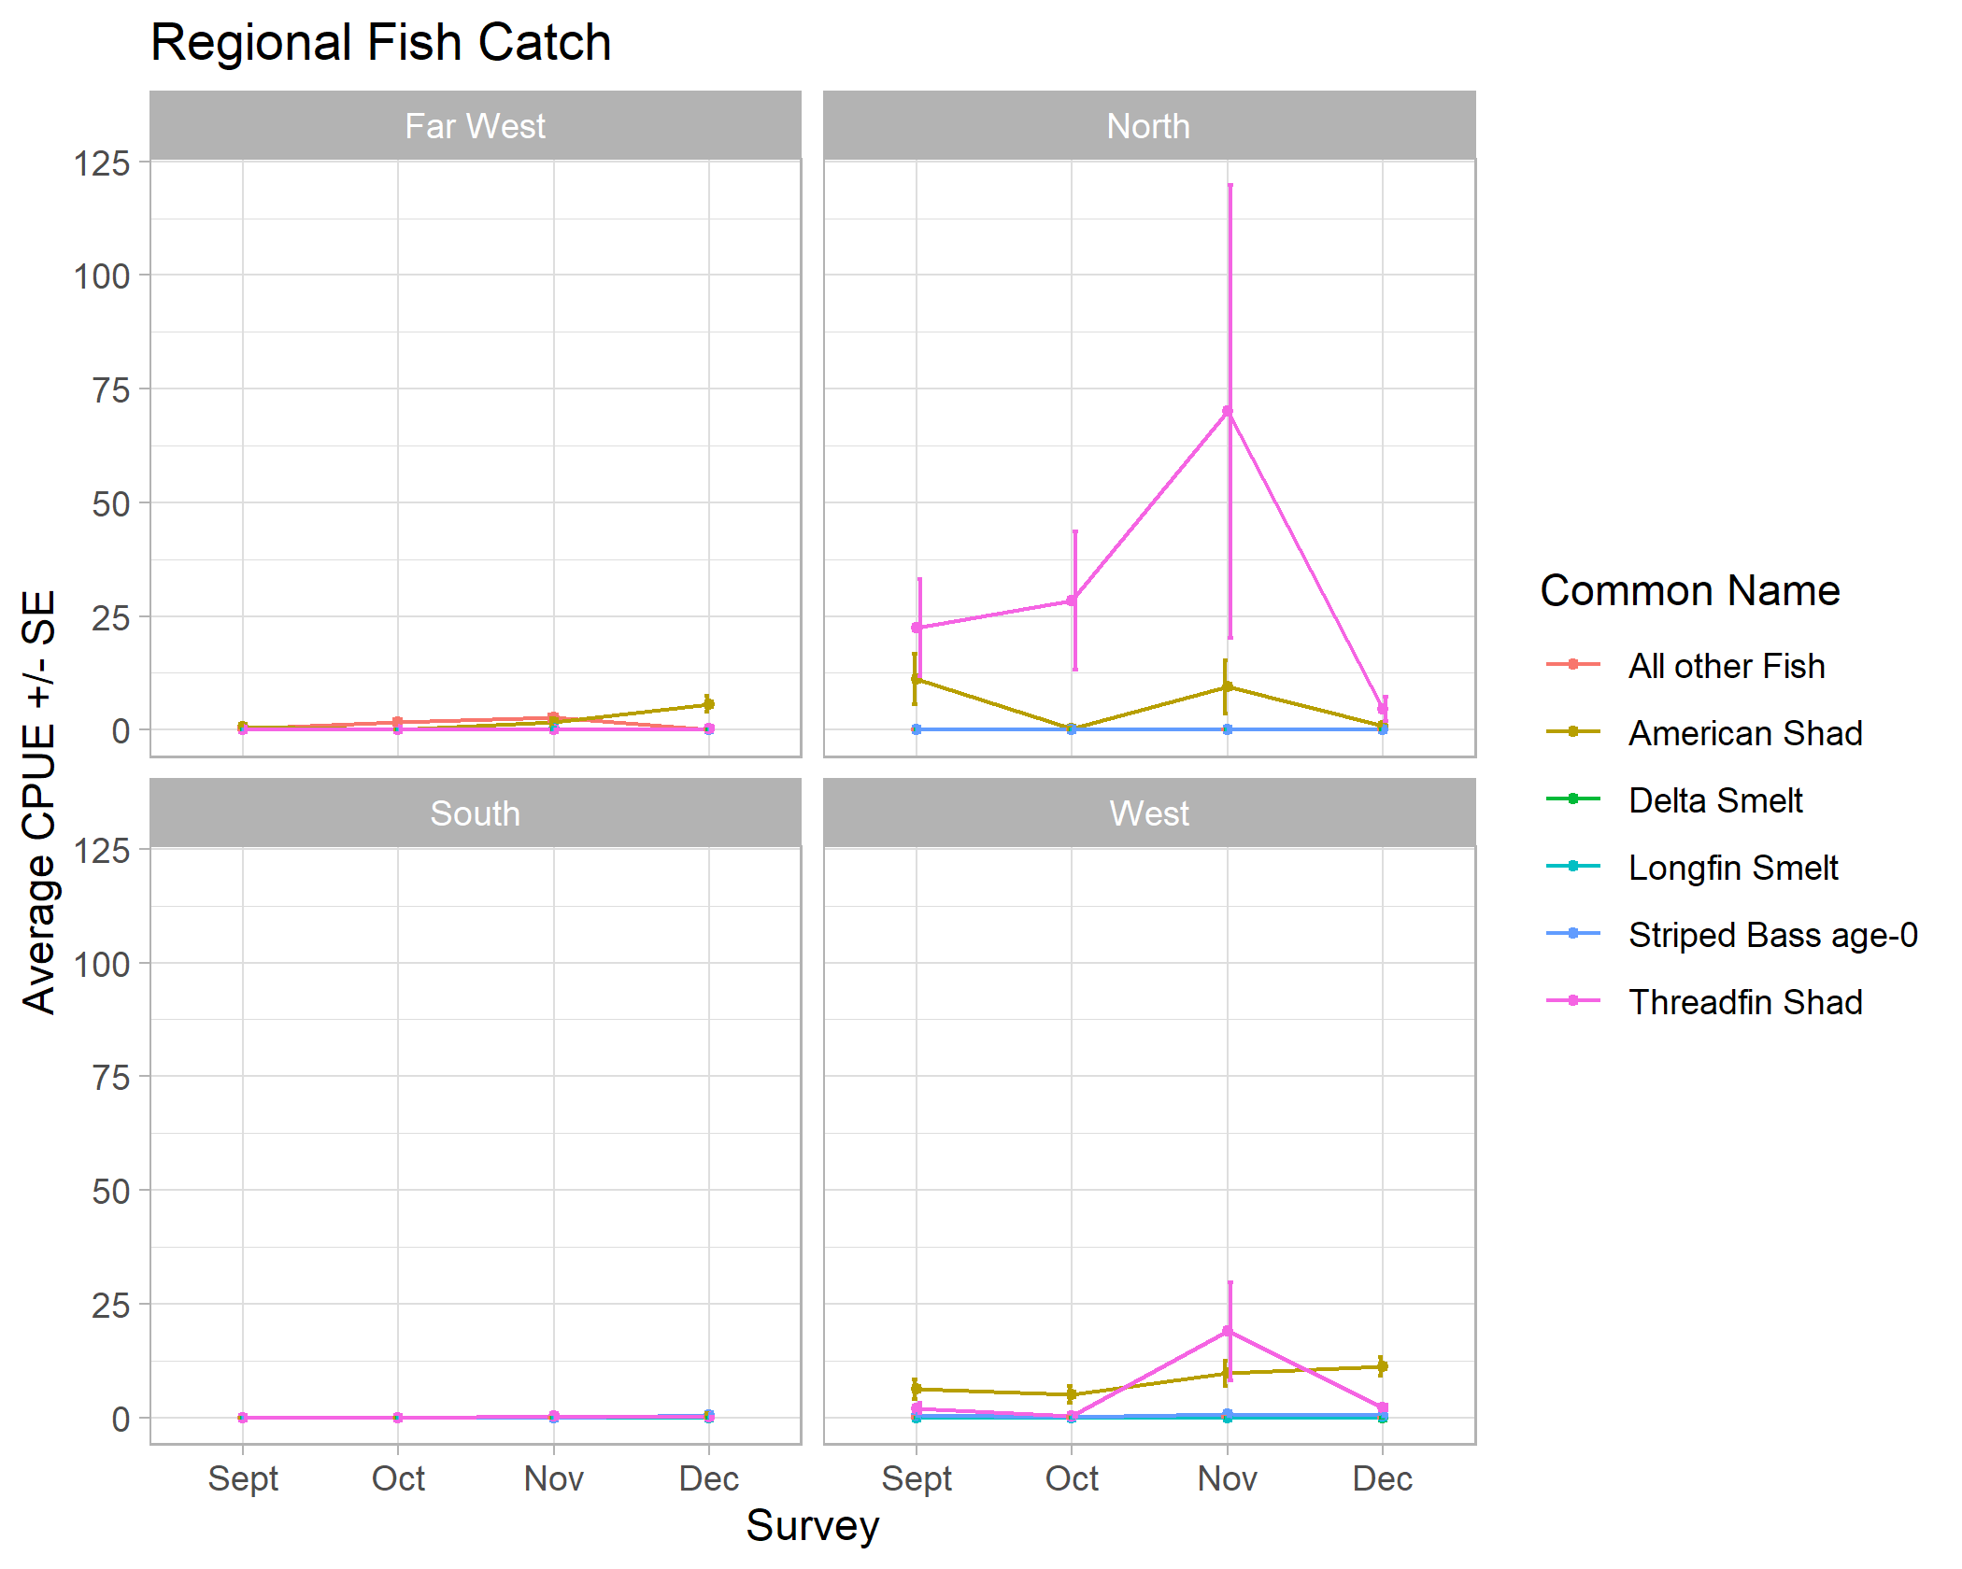

Figure 11. Regional fish catch for the 2020 FMWT survey organized by species used for index calculations. Lines represent monthly average catch per unit effort (CPUE) values and error bars represent +/- standard error.

Table 2. Total monthly fish catch during the 2020 FWMT season.

| Species | September | October | November | December | Total | Total percent |
| --- | --- | --- | --- | --- | --- | --- |
| Northern Anchovy | 607 | 3,096 | 5,730 | 29 | 9,462 | 76.7 |
| Threadfin Shad | 267 | 280 | 1,041 | 103 | 1,691 | 13.7 |
| American Shad | 247 | 116 | 316 | 324 | 1,003 | 8.1 |
| Striped Bass age-0 | 11 | 4 | 14 | 20 | 49 | 0.4 |
| Striped Bass age-1 | 7 | 11 | 3 | 6 | 27 | 0.2 |
| Topsmelt | 4 | 1 | 4 | 10 | 19 | 0.2 |
| Wakasagi | 4 | 4 | 4 | 0 | 12 | 0.1 |
| Longfin Smelt | 0 | 0 | 7 | 4 | 11 | 0.1 |
| Pacific Herring | 2 | 1 | 6 | 1 | 10 | 0.1 |
| White Catfish | 0 | 3 | 5 | 2 | 10 | 0.1 |
| Striped Bass age-2 | 6 | 2 | 0 | 0 | 8 | 0.1 |
| Bat Ray | 4 | 2 | 0 | 0 | 6 | 0.0 |
| Shiner Perch | 0 | 0 | 4 | 2 | 6 | 0.0 |
| California Halibut | 2 | 0 | 1 | 1 | 4 | 0.0 |
| Jacksmelt | 2 | 0 | 0 | 0 | 2 | 0.0 |
| Bay Goby | 1 | 0 | 0 | 0 | 1 | 0.0 |
| Bluegill | 0 | 1 | 0 | 0 | 1 | 0.0 |
| Diamond Turbot | 0 | 1 | 0 | 0 | 1 | 0.0 |
| Goby (unid) | 1 | 0 | 0 | 0 | 1 | 0.0 |
| Golden Shiner | 0 | 0 | 0 | 1 | 1 | 0.0 |
| Hitch | 0 | 1 | 0 | 0 | 1 | 0.0 |
| Pacific Staghorn Sculpin | 1 | 0 | 0 | 0 | 1 | 0.0 |
| Redear Sunfish | 0 | 0 | 1 | 0 | 1 | 0.0 |
| Striped Bass age-3+ | 0 | 0 | 1 | 0 | 1 | 0.0 |

## Invertebrates

Similarly, the invertebrate catch was dominated by catch of the Siberian prawn (*Exopalaemon modestus*) followed by *Maeotias* jellies which were mostly caught in the DWSC and together comprised 96% of total catch (Table 3, Fig. 13). Otherwise, *Crangon* shrimp were the third most abundant species caught. Other species comprised less than 1% of the total catch.

Again, life histories of the invertebrates caught likely explain their spatial distribution within the estuary. The Siberian prawn historically has been found estuary-wide, but tends to be found in lower salinity habitat than other shrimps (Brown and Hieb 2014). *Crangon* shrimp generally are associated with brackish water but can tolerate freshwater (Hatfield 1985). *Maeotias* jellies are considered a brackish species but can tolerate a wide range of temperature and salinity conditions. Increased *Maeotias* abundance, later bloom termination, and increased duration of medusae bloom are associated with conditions of low to moderate salinity (<1-10 ppt) and higher temperatures (≥19°C; Schroeter (2008)) which may explain their high abundance in the DWSC in September.

Table 3. Total monthly invertebrate catch during the 2020 FWMT season.

| Species | September | October | November | December | Total | Total percent |
| --- | --- | --- | --- | --- | --- | --- |
| *Exopalaemon modestus* | 2,399 | 2,000 | 4,404 | 276 | 9,079 | 77.6 |
| *Maeotias spp.* | 2,029 | 76 | 46 | 1 | 2,152 | 18.4 |
| *Crangon spp.* | 284 | 2 | 1 | 1 | 288 | 2.5 |
| Comb Jelly | 0 | 0 | 4 | 96 | 100 | 0.9 |
| *Polyorchis spp.* | 0 | 0 | 7 | 61 | 68 | 0.6 |
| Shrimp (unid) | 2 | 7 | 0 | 1 | 10 | 0.1 |
| Jellyfish | 0 | 0 | 1 | 0 | 1 | 0.0 |

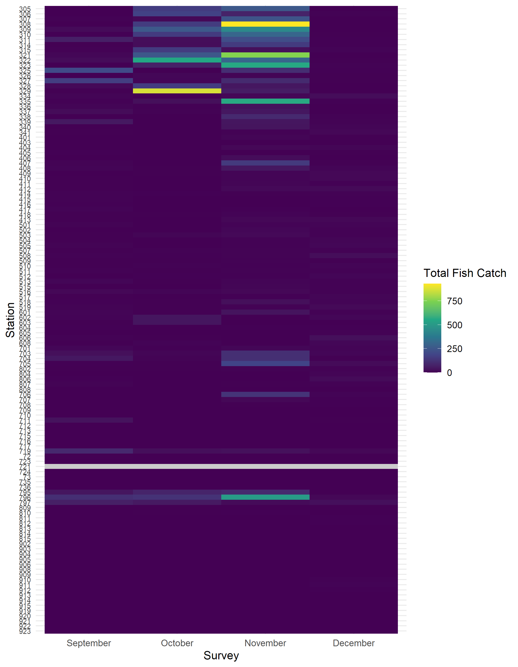

Figure 12. Heatmap of raw total fish catch by station recorded during the 2020 FMWT season. Grey values indicate missing data. San Pablo Bay and the northern part of the DWSC had the highest fish catch.

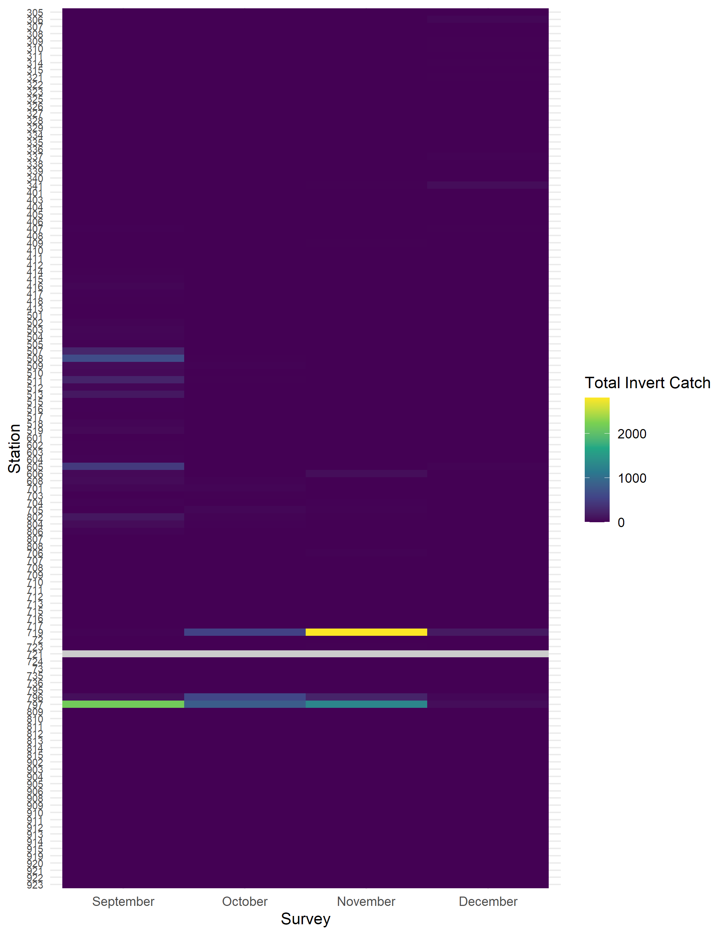

Figure 13. Heatmap of raw total invertebrate catch by station recorded during the 2020 FMWT season. Grey values indicate missing data. The northern part of the DWSC had the highest invertebrate catch.

# Acknowledgments

We thank all personnel involved in this project. Their hard work and dedication to accurate and timely data collection has provided continued success for this long running survey.

Cole Anderson; Spencer Breining-Aday; Christina Burdi; Ken Flowers; Mike Grady; Dave Hull; Spencer Lewis; Paul Macias; Tim Malinich; Chris Newbrough; Steve Slater; Ramiro Soto; and Maria Velazquez

# References

Baker PF, Ligon FK, Speed TP. 1995. Estimating the influence of temperature on the survival of Chinook salmon smolts (*Oncorhynchus tshawytscha*) migrating through the Sacramento–San Joaquin River Delta of California. Canadian Journal of Fisheries and Aquatic Sciences. 52(4):855–863. doi:[c9p7fb](https://doi.org/c9p7fb).

Baxter R, Breuer R, Brown L, Conrad L, Feyrer F, Fong S, Gehrts K, Grimaldo L, Herbold B, Hrodey P, et al. 2010. Interagency ecological program 2010 pelagic organism decline work plan and synthesis of results. California Department of Water Resources. <http://www.science.calwater.ca.gov/iep/docs/ FinalPOD2010Workplan12610.pdf>.

Bennett W. 2005. Critical assessment of the delta smelt population in the San-Francisco Estuary, California. San Francisco Estuary and Watershed Science. 3(2):1–71. doi:[10.15447/sfews.2005v3iss2art1](https://doi.org/10.15447/sfews.2005v3iss2art1). <https://doi.org/10.15447/sfews.2005v3iss2art1>.

Bennett W, Kimmerer W, Burau J. 2002. Plasticity in vertical migration by native and exotic estuarine fishes in a dynamic low‐salinity zone. Limnology and Oceanography. 47(5):1496–1507. doi:[fwt4hg](https://doi.org/fwt4hg).

Brown T, Hieb K. 2014. Status of the Siberian Prawn, *Exopalaemon modestus*, in the San Francisco Estuary. San Francisco Estuary and Watershed Science. 12(1). doi:[gmbmr6](https://doi.org/gmbmr6). <https://escholarship.org/uc/item/36t046cq>.

Clutton-Brock T, Sheldon BC. 2010. Individuals and populations: the role of long-term, individual-based studies of animals in ecology and evolutionary biology. Trends in ecology & evolution. 25(10):562–573. doi:[cbdd3b](https://doi.org/cbdd3b).

Cody ML, Smallwood JA. 1996. Long-term studies of vertebrate communities. Academic Press.

Ducklow HW, Doney SC, Steinberg DK. 2009. Contributions of long-term research and time-series observations to marine ecology and biogeochemistry. Annual Review of Marine Science. 1:279–302. doi:[d2dmm5](https://doi.org/d2dmm5).

Feyrer F, Newman K, Nobriga M, Sommer T. 2011. Modeling the Effects of Future Outflow on the Abiotic Habitat of an Imperiled Estuarine Fish. Estuaries and Coasts. 34(1):120–128. doi:[10.1007/s12237-010-9343-9](https://doi.org/10.1007/s12237-010-9343-9). <https://doi.org/10.1007/s12237-010-9343-9>.

Feyrer F, Nobriga ML, Sommer TR. 2007. Multidecadal trends for three declining fish species: habitat patterns and mechanisms in the San Francisco Estuary, California, USA. Can J Fish Aquat Sci. 64(4):723–734. doi:[10.1139/f07-048](https://doi.org/10.1139/f07-048). [accessed 2020 Apr 27]. <https://doi.org/10.1139/f07-048>.

Ger KA, Teh SJ, Baxa DV, Lesmeister S, Goldman CR. 2010. The effects of dietary *Microcystis aeruginosa* and microcystin on the copepods of the upper San Francisco Estuary. Freshwater Biology. 55(7):1548–1559. doi:<https://doi.org/10.1111/j.1365-2427.2009.02367.x>. <https://onlinelibrary.wiley.com/doi/abs/10.1111/j.1365-2427.2009.02367.x>.

Grimaldo L, Feyrer F, Burns J, Maniscalco D. 2017. Sampling uncharted waters: Examining rearing habitat of larval longfin smelt (*Spirinchus thaleichthys*) in the upper San Francisco Estuary. Estuaries and Coasts. 40(6):1771–1784. doi:[gb29xn](https://doi.org/gb29xn).

Hatfield S. 1985. Seasonal and interannual variation in distribution and population abundance of the shrimp *Crangon franciscorum* in San Francisco Bay. In: Cloern J, Nichols F, editors. Temporal Dynamics of an Estuary: San Francisco Bay. Dordrecht: Springer Netherlands. (Developments in Hydrobiology). p. 199–210. <https://doi.org/10.1007/978-94-009-5528-8_12>.

Hobbs JA, Bennett WA, Burton JE. 2006. Assessing nursery habitat quality for native smelts (Osmeridae) in the low-salinity zone of the San Francisco estuary. Journal of Fish Biology. 69(3):907–922. doi:<https://doi.org/10.1111/j.1095-8649.2006.01176.x>. <https://onlinelibrary.wiley.com/doi/abs/10.1111/j.1095-8649.2006.01176.x>.

Hobbs JA, Moyle PB. 2015. Last Days of the Longfin? Last Days of the Longfin? <https://www.newsdeeply.com/water/community/2015/09/08/last-days-of-the-longfin>.

Hofmann GE, Blanchette CA, Rivest EB, Kapsenberg L. 2013. Taking the pulse of marine ecosystems: The importance of coupling long-term physical and biological observations in the context of global change biology. Oceanography. 26(3):140–148. doi:[f4899f](https://doi.org/f4899f).

Hughes BB, Beas-Luna R, Barner AK, Brewitt K, Brumbaugh DR, Cerny-Chipman EB, Close SL, Coblentz KE, de Nesnera KL, Drobnitch ST, et al. 2017. Long-Term Studies Contribute Disproportionately to Ecology and Policy. BioScience. 67(3):271–281. doi:[f9x4pb](https://doi.org/f9x4pb). <https://doi.org/10.1093/biosci/biw185>.

Jassby AD, Kimmerer WJ, Monismith SG, Armor C, Cloern JE, Powell TM, Schubel JR, Vendlinski TJ. 1995. Isohaline Position as a Habitat Indicator for Estuarine Populations. Ecological Applications. 5(1):272–289. doi:[10.2307/1942069](https://doi.org/10.2307/1942069). <https://esajournals.onlinelibrary.wiley.com/doi/abs/10.2307/1942069>.

Jeffries KM, Connon RE, Davis BE, Komoroske LM, Britton MT, Sommer TR, Todgham AE, Fangue NA. 2016. Effects of high temperatures on threatened estuarine fishes during periods of extreme drought. Journal of Experimental Biology. 219(11):1705–1716. doi:[f8p7p5](https://doi.org/f8p7p5). <https://jeb.biologists.org/content/219/11/1705>.

Kimmerer WJ. 2002 a. Effects of freshwater flow on abundance of estuarine organisms: physical effects or trophic linkages? Marine Ecology Progress Series. 243:39–55. doi:[10.3354/meps243039](https://doi.org/10.3354/meps243039). <https://www.jstor.org/stable/24866158>.

Kimmerer WJ. 2002 b. Physical, biological, and management responses to variable freshwater flow into the San Francisco Estuary. Estuaries. 25(6):1275–1290. doi:[10.1007/bf02692224](https://doi.org/10.1007/bf02692224). <https://doi.org/10.1007/BF02692224>.

Kimmerer WJ, Burau JR, Bennett WA. 1998. Tidally oriented vertical migration and position maintenance of zooplankton in a temperate estuary. Limnology and Oceanography. 43(7):1697–1709. doi:[b8h3h7](https://doi.org/b8h3h7). <https://aslopubs.onlinelibrary.wiley.com/doi/abs/10.4319/lo.1998.43.7.1697>.

Latour R. 2016. Statistical modeling of delta smelt (*Hypomesus transpacificus*) survey data in the San Francisco-San Joaquin Delta, with reference to temporal and spatial autocorrelation. Hayes, VA: Latour Environmental Consulting Report No.: DWR-1258.

Lehman PW, Boyer G, Hall C, Waller S, Gehrts K. 2005. Distribution and toxicity of a new colonial *Microcystis aeruginosa* bloom in the San Francisco Bay Estuary, California. Hydrobiologia. 541(1):87–99. doi:[10.1007/s10750-004-4670-0](https://doi.org/10.1007/s10750-004-4670-0). <https://doi.org/10.1007/s10750-004-4670-0>.

Lehman PW, Boyer G, Satchwell M, Waller S. 2008. The influence of environmental conditions on the seasonal variation of *Microcystis* cell density and microcystins concentration in San Francisco Estuary. Hydrobiologia. 600(1):187–204. doi:[10.1007/s10750-007-9231-x](https://doi.org/10.1007/s10750-007-9231-x). <https://doi.org/10.1007/s10750-007-9231-x>.

Lehman PW, Teh SJ, Boyer GL, Nobriga ML, Bass E, Hogle C. 2010. Initial impacts of *Microcystis aeruginosa* blooms on the aquatic food web in the San Francisco Estuary. Hydrobiologia. 637(1):229–248. doi:[10.1007/s10750-009-9999-y](https://doi.org/10.1007/s10750-009-9999-y). <https://doi.org/10.1007/s10750-009-9999-y>.

Lewis L, Barros A, Willmes M, Denney C, Parker C, Bisson M, Hobbs J, Finger A, Auringer G, Benjamin A. 2019. Interdisciplinary Studies on Longfin Smelt in the San Francisco Estuary.

Likens GE. 2012. Long-term studies in ecology. Springer.

Lindenmayer DB, Likens GE, Andersen A, Bowman D, Bull CM, Burns E, Dickman CR, Hoffmann AA, Keith DA, Liddell MJ. 2012. Value of long-term ecological studies. Austral Ecology. 37(7):745–757. doi:[f2zphv](https://doi.org/f2zphv).

MacNally R, Thomson JR, Kimmerer WJ, Feyrer F, Newman KB, Sih A, Bennett WA, Brown L, Fleishman E, Culberson SD, et al. 2010. Analysis of pelagic species decline in the upper San Francisco Estuary using multivariate autoregressive modeling (MAR). Ecological Applications. 20(5):1417–1430. doi:[dgm43f](https://doi.org/dgm43f). <https://esajournals.onlinelibrary.wiley.com/doi/abs/10.1890/09-1724.1>.

Magurran AE, Baillie SR, Buckland ST, Dick JM, Elston DA, Scott EM, Smith RI, Somerfield PJ, Watt AD. 2010. Long-term datasets in biodiversity research and monitoring: assessing change in ecological communities through time. Trends in ecology & evolution. 25(10):574–582. doi:[dqxgb5](https://doi.org/dqxgb5).

Mahardja B, Tobias V, Khanna S, Mitchell L, Lehman P, Sommer T, Brown L, Culberson S, Conrad JL. 2021. Resistance and resilience of pelagic and littoral fishes to drought in the San Francisco Estuary. Ecological Applications. 31(2):e02243. doi:[10.1002/eap.2243](https://doi.org/10.1002/eap.2243).

McGowan JA. 1990. Climate and change in oceanic ecosystems: the value of time-series data. Trends in ecology & evolution. 5(9):293–299. doi:[fgv9wf](https://doi.org/fgv9wf).

Morris T, Civiello M. 2013. *Microcystis aeruginosa* status and trends during the Fall Midwater Trawl Survey and a comparison to trends in the Summer Townet Survey. IEP Newsletter. 2:33–39.

Moyle PB. 2002. Inland fishes of California: revised and expanded. Univ of California Press.

Moyle P, Baxter R, Sommer T, Foin T, Matern S. 2004. Biology and Population Dynamics of Sacramento Splittail (*Pogonichthys macrolepidotus*) in the San Francisco Estuary: A Review. San Francisco Estuary and Watershed Science. 2(2):1–47. doi:[10.15447/sfews.2004v2iss2art3](https://doi.org/10.15447/sfews.2004v2iss2art3). <https://escholarship.org/uc/item/61r48686>.

Nally R, Thomson J, Kimmerer W, Feyrer F, Newman K, Sih A, Bennett W, Brown L, Fleishman E, Culberson S, et al. 2010. Analysis of pelagic species decline in the upper San Francisco Estuary using multivariate autoregressive modeling (MAR). Ecological Applications. 20(5):1417–1430. doi:[10.1890/09-1724.1](https://doi.org/10.1890/09-1724.1). <https://esajournals.onlinelibrary.wiley.com/doi/abs/10.1890/09-1724.1>.

Nelson MP, Vucetich JA, Peterson RO, Vucetich LM. 2011. The Isle Royale Wolf–Moose Project (1958-present) and the wonder of long-term ecological research. Endeavour. 35(1):31. doi:[cbrwv2](https://doi.org/cbrwv2).

Nobriga M, Sommer T, Feyrer F, Fleming K. 2008. Long-term trends in summertime habitat suitability for delta smelt, *Hypomesus transpacificus*. San Francisco Estuary and Watershed Science. 6(1):13. doi:[ggvxdg](https://doi.org/ggvxdg).

Schoellhamer DH. 2000. Influence of salinity, bottom topography, and tides on locations of estuarine turbidity maxima in northern San Francisco Bay. In: McAnally WH, Mehta AJ, editors. Proceedings in Marine Science. Vol. 3. Elsevier. (Coastal and Estuarine Fine Sediment Processes). p. 343–357. <https://www.sciencedirect.com/science/article/pii/S1568269200801308>.

Schroeter R. 2008. Biology and Long-Term Trends of Alien Hydromedusae and Striped Bass in a Brackish Tidal Marsh in the San Francisco Estuary. University of California, Davis. <https://escholarship.org/uc/item/5gh43754>.

Sommer T, Armor C, Baxter R, Breuer R, Brown L, Chotkowski M, Culberson S, Feyrer F, Gingras M, Herbold B, et al. 2007. The Collapse of Pelagic Fishes in the Upper San Francisco Estuary: El Colapso de los Peces Pelagicos en La Cabecera Del Estuario San Francisco. Fisheries. 32(6):270–277. doi:[10.1577/1548-8446(2007)32[270:TCOPFI]2.0.CO;2](https://doi.org/10.1577/1548-8446(2007)32[270:TCOPFI]2.0.CO;2). <https://doi.org/10.1577/1548-8446(2007)32[270:TCOPFI]2.0.CO;2>.

Stevens D. 1977. Striped Bass (*Monrone saxatilis*) monitoring techniques in the Sacramento-San Joaquin Estuary. In: Van Winkle W, editor. Proceedings of the conference on assessing the effects of power-plant-induced mortality on fish populations. New York, New York: Pergamon Press. p. 91–109.

Swanson C, Reid T, Young PS, Cech Jr JJ. 2000. Comparative environmental tolerances of threatened delta smelt (*Hypomesus transpacificus*) and introduced wakasagi (*H. nipponensis*) in an altered California estuary. Oecologia. 123(3):384–390. doi:[ch6dcg](https://doi.org/ch6dcg).

Tempel T, Malinich T, Burns J, Barros A, Burdi C, Hobbs J. 2021. The value of long-term monitoring of the San Francisco Estuary for Delta Smelt and Longfin Smelt. California Fish and Wildlife Journal.(CESA Special Issue):148–171. doi:[gk55qp](https://doi.org/gk55qp). <https://nrm.dfg.ca.gov/FileHandler.ashx?DocumentID=193400&inline>.

Thomson J, Kimmerer W, Brown L, Newman KB, Nally RM, Bennett W, Feyrer F, Fleishman E. 2010. Bayesian change point analysis of abundance trends for pelagic fishes in the upper San Francisco Estuary. Ecological Applications. 20(5):1431–1448. doi:[10.1890/09-0998.1](https://doi.org/10.1890/09-0998.1). <https://esajournals.onlinelibrary.wiley.com/doi/abs/10.1890/09-0998.1>.

Turner JL, Chadwick HK. 1972. Distribution and abundance of young-of-the-year striped bass, Morone saxatilis, in relation to river flow in the Sacramento-San Joaquin estuary. Transactions of the American Fisheries Society. 101(3):442–452.